Table of Contents
Title Page I
Certificate Page II
Report of % similarity prepared using Turnitin III
Table of Contents… IV
List of Figures… VII
List of Tables… VIII
Contents

Introduction 1
  - Introduction to analytical method development: 1
  - Introduction of UV spectrophotometry as method of analysis 3
    - Principle of UV spectroscopy 3
    - Basic instrumentation of UV spectrophotometer: 5
    - Different methods for analysis of single component and multi component samples by UV spectroscopy 5
    - Multicomponent Analysis method: 6
  - Partial Least Square (PLS) Method 12
    - History of partial least square: 12
    - Introduction of partial least square 12
    - Partial least square 13
  - Introduction to chromatography as a separation and quantification technique: 15

    - High performance liquid chromatography as a choice of method for analysis 15
    - Modes and types of HPLC 16
    - Types of elution techniques in HPLC 18
    - Principle of High-performance liquid chromatography 18
    - Instrumentation of HPLC 19
    - Introduction to system suitability parameters 22
  - Introduction to Analytical method validation 24
    - Data elements required for analytical method validation 30
  - Introduction to Drug profile 32
    - Introduction of Diltiazem malate 32
    - Drug profile of Enalapril malate 33
    - Marketed Formulation 35
- Review of literature 36
  - Review of analytical method for diltiazem malate and enalapril malate 36
  - Summary of PSAR report 41
- Rational behind selection of project 43
- Aim and Objectives 44
- Instrument Specification 45
  - Instrumental Specification of Double Beam Spectrophotometer 45
  - Instrumental Specification of High-Performance Liquid Chromatography: 45
  - Instrumental Specification of Weighing Balance 46
- Identification of Drug 47
  - Identification of Diltiazem malate (DIL) and Enalapril malate (ENA) 47
    - Identification by Melting point: 47
    - Identification by solubility 47
    - Identification by UV Spectra 48
    - Identification by IR spectra 50
- Materials and Methods: 54
  - Preparation of dilution scheme for Diltiazem malate: 54
  - Preparation of dilution scheme for Enalapril maleate: 54
  - Design of mixture for Partial Least Square Method (PLS): 54
    - Composition of calibration sample 55
  - Optimization by PLS method: 58
  - Preparation of validation set for diltiazem malate an enalapril malate: 59
  - Accuracy study of Diltiazem malate and Enalapril maleate: 60
  - Assay preparation of DIL and ENA by PLS method: 60
- Result and Discussion 61
  - UV – spectra of Diltiazem malate and Enalapril malate for PLS Method: 61
  - Training set of Diltiazem malate and Enalapril maleate: 62
  - Eigenvalues of Diltiazem malate and Enalapril maleate by Principal Component Analysis (PCA) 64
  - Statistical analysis of Enalapril maleate by PLS method: 65
  - Statistical analysis of Diltiazem malate by PLS method: 67
  - Accuracy data of DIL and ENA at 80, 100 and 120% of target concentratio 69
  - Assay data of DIL and ENA: 69
  - Validation set analysis by PLS method for Diltiazem malate 70
  - Validation set analysis by PLS method for Enalapril malate 71
- Plan of work 72
- Comment Compliance Report: 73
- Reference 74

List of Figures

Figure 1. Block diagram of UV spectrophotometer 5
Figure 2: Overview of different methods of analysis 5
Figure 3: Overview of simultaneous equation method 6
Figure 4: Overview of Q-Absorbance method 8
Figure 5: Overview of Dual wavelength method 9
Figure 6: Overview of Derivative spectroscopy method 10
Figure 7: Overview of ratio spectra derivative spectroscopy 11
Figure 8: Instrumentation of HPLC 19
Figure 9: Diagrammatical representation of Linearity 26
Figure 10: Diagrammatical representation of Range 26
Figure 11: General representation of LOD and LOQ 28
Figure 12: Regression line method for determination of LOD and LOQ 29
Figure 13 UV - spectra of Diltiazem malate 48
Figure 14 Recorded UV absorption spectra of Enalapril malate. (100µg/ml) 49
Figure 15 standard UV - spectra of Enalapril malate 49
Figure 16 FT-IR spectra of Diltiazem malate 50
Figure 17 Standard IR spectra of Diltiazem malate 50
Figure 18 FT - IR Spectra of Enalapril malate (sample) 52
Figure 19 Standard IR spectra of enalapril malate 52
Figure 20 UV - Spectra of DIL and ENA by PLS method 61
Figure 21 standard residual matrix 66
Figure 22 Predicted standard residual matrix 66
Figure 23 correlation matrix between Actual and Predicted concentration 66
Figure 24 Standardized residual matrix of DIL 68
Figure 25 Predicted standard residual matrix of ENA 68
Figure 26 Correlation matrix between Actual and Predicted concentration 68
Figure 27 Standardized and Predicted validation matrix of DIL 70
Figure 28 Standardized and Predicted validation matrix of ENA 71

List of Tables
Table 1-1: System suitability parameters in HPLC 22
Table 1-2: Consideration for analytical method validation 31
Table 1-3 Introduction of Diltiazem malate 32
Table 1-4 Marketed Formulation 35
Table 2-1 official method for Diltiazem malate 36
Table 2-2 Nonofficial method for diltiazem malate 37
Table 2-3 Official method for enalapril maleate 38
Table 2-4 Nonofficial method for enalapril maleate 39
Table 2-5 Summary of PSAR report 41
Table 5-1 Instrumental Specification of Double Beam Spectrophotometer 45
Table 5-2 Instrumental Specification of High-Performance Liquid Chromatography
. 45
Table 5-3 Instrumental Specification of Weighing Balance 46
Table 6-1 identification by Melting point 47
Table 6-2 Interpretation of IR spectra of Diltiazem malate 51
Table 6-3 Interpretation of IR spectra of Enalapril malate 53
Table 7-1 Dilution scheme of Diltiazem malate 54
Table 7-2 Dilution scheme of Enalapril malate 54
Table 7-3 composition of calibration sample of DIL and ENA. 55
Table 7-4 Preparation of Set 1 56
Table 7-5 Preparation of Set 2 56
Table 7-6 Preparation of Set 3 56
Table 7-7 Preparation of Set 4 57
Table 7-8 Preparation of Set 5 57
Table 7-9 Preparation of validation set for DIL and ENA 59
Table 7-10 Accuracy study of DIL and ENA 60
Table 7-11 Assay preparation table for DIL and ENA 60
Table 7-12 Test Solution of DIL and ENA 60
Table 8-1 Training set of DIL and ENA 62

Table 8-2 Eigenvalue of DIL and ENA by PCA 64
Table 8-3 Statistical analysis of ENA by PLS Method 65
Table 8-4 Statistical analysis of DIL by PLS method 67
Table 8-5 Accuracy data of DIL and ENA 69
Table 8-6 assay data of DIL and ENA 69
Table 8-7 Validation set analysis by PLS method foe DIL 70
Table 8-8 Validation set analysis by PLS method for ENA 71

Introduction:

  - Introduction to analytical method development:[2]
Analytical chemistry is often described as the “area of chemistry responsible for Characterizing the composition of matter, both qualitatively (what is present) and quantitatively (how much is present)”. Analytical chemistry is not a separate branch of chemistry, but simply the application of chemical knowledge. In other words, Analytical Chemistry is defined as “the science and the art of determining the composition of materials in terms of the elements or compounds contained.”
Analytical method development can be defined as the procedure for selection of an accurate assay method for determination of the constitution present in the formulation. Analytical method development is widely used procedure for demonstration of acceptability of analytical methods utilized in laboratory for measurement of concentration of the sample. Method of analysis should be utilized within Good Manufacturing Practice and Good Laboratory Practice criteria. Development of analytical method must follow the protocols and criteria for acceptance which is mentioned in International Conference on Harmonization guideline that is Q2(R1).
Physico-chemical methods are useful in study of physical phenomenon that generates as a result of chemical reactions. Optical and chromatographic methods are most important from all of the physico-chemical methods.
Mandatory requirements for modern pharmaceutical analysis:

- The analysis should be less tedious.

- Pharmacopoeial criteria for accuracy should be fulfilled by the selected method of analysis.
- The method of analysis should not be too costly.

- The nature of analysis method which is selected should be selective and precise.

Physico-chemical methods of analysis are able to meet these requirements, having advantage of their universal nature that can be utilized for analysis of organic compounds with their diverse structure. Small scale industries generally prefer visible spectrophotometry as the method of analysis mainly due to these two reasons:
  - Low cost of equipment used.
  - Maintenance problems are minimal.

Need for analytical method:
The quantity of drugs launched into the market is continuously enhancing per year. The launched drugs may be a kind of either new entities or partial structural changes or improvement of the already available drug. Sometimes, there are so much year passing from the date of establishment of drug molecule to their entry or registration in pharmacopoeias. During this time period, analytical methods as well as standard parameters for this kind of drugs may not be included in the pharmacopoeias. Development of new analytical method becomes a mandatory requirement for this kind of drugs in brief, the reasons for the development of newer methods of drug analysis are:

- A proper analytical procedure for the drug may not be available in the literature due to patent regulations.
- Analytical methods for the quantification of the drug in biological fluids may not be available.
- The drug or drug combination may not be official in any pharmacopoeias.
- Analytical procedures may not be given for the drug in the form of a formulation because of the intervention created due to excipients used in formulation.
- No methods are available for the drug with combination of another drugs.
- Costly reagents and solvents are utilized in present analytical procedure available for drug.
- Analytical techniques that are generally used for drug analysis are biological

and microbiological methods, radioactive methods, physical methods and miscellaneous techniques like conventional titrimetric, gravimetric and polarimetric methods.

Introduction of UV spectrophotometry as method of analysis:[1, 3-9]

Principle of UV spectroscopy:
Molecules having π electrons or atoms which carrying unshared electron pairs generally absorbs electromagnetic radiation having the range between 200 nm to 800 nm and it forms the basis for ultraviolet-visible spectroscopy. UV spectroscopy mainly concerned with valence electrons. Now, some pharmaceutical and biological substance which contain valence electrons are more preferred to absorb UV-visible radiation. So, in pharmaceutical Analysis, UV-Vis spectrophotometry is one of the most widely used technique. Area of concern in ultraviolet spectroscopy it to measure the amount of radiation which is absorbed through a substance present in the solution either in ultraviolet region i.e. 190 nm to 380 nm or visible region i.e. 380 nm to 800 nm.
Valence electrons which are present in organic compound are of three types:
- σ – electrons
- π – electrons
- η – electrons.
When irradiation of UV-Visible light is carried out on molecules, absorption of light takes place only when the energy of light reaches the similar level of energy that is required by molecule to induce electronic transition. The instruments which are utilized for measurement of the intensity ratio of two beams of light in the UV- Visible region are known as UV-Visible spectrophotometers.
Lambert’s Law and Beer’s law are two separate laws governing absorption by UV radiation.

Lambert’s Law:
Statement: When monochromatic light travels through a transparent medium, intensity of light which is emitted decreases as the thickness of the medium increases.

Where,

In dI0/dIt = kl

I0 = Intensity of the incident light
It = Intensity of the transmitted light l = Thickness of the medium
k = Proportionality factor

Beer’s Law:
Statement: When monochromatic light travels through a transparent medium, intensity of light which is emitted decreases as the concentration of the absorbing substance increases.

Where,

Log I0/It = act

I0 = Intensity of the incident light
It = Intensity of the transmitted light t = Thickness of the medium
c = Concentration of the analyte
a = Constant which depends upon the method of expression of the conc.

Where thickness(t) can also be denoted as path length(b) and logarithmic ratio of I0 and it is known as absorbance (A).

A = abc
A strong relationship between the amount of light absorbed and concentration of analyte creates the base for most of the analytical application of the spectroscopy deals with molecular electronic absorption.
The properties of absorbance spectra like:
- Spectral position
- Molar absorptivity
- Breadth and shape of the absorption band.
are directly connected to environment and structure of the molecule. Therefore, they are used to perform the estimation qualitatively. Physical as well as chemical contents of the radiation absorbing molecule can be determined by changes in the absorption spectra as a result of any alteration and modification of the molecule.

Basic instrumentation of UV spectrophotometer:
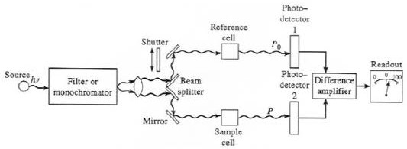

Figure 1. Block diagram of UV spectrophotometer

Different methods for analysis of single component and multi component samples by UV spectroscopy:
Both single component as well as multi component samples can be estimated by UV spectroscopy. Different methods of analysis for estimation of this kind of samples are available.
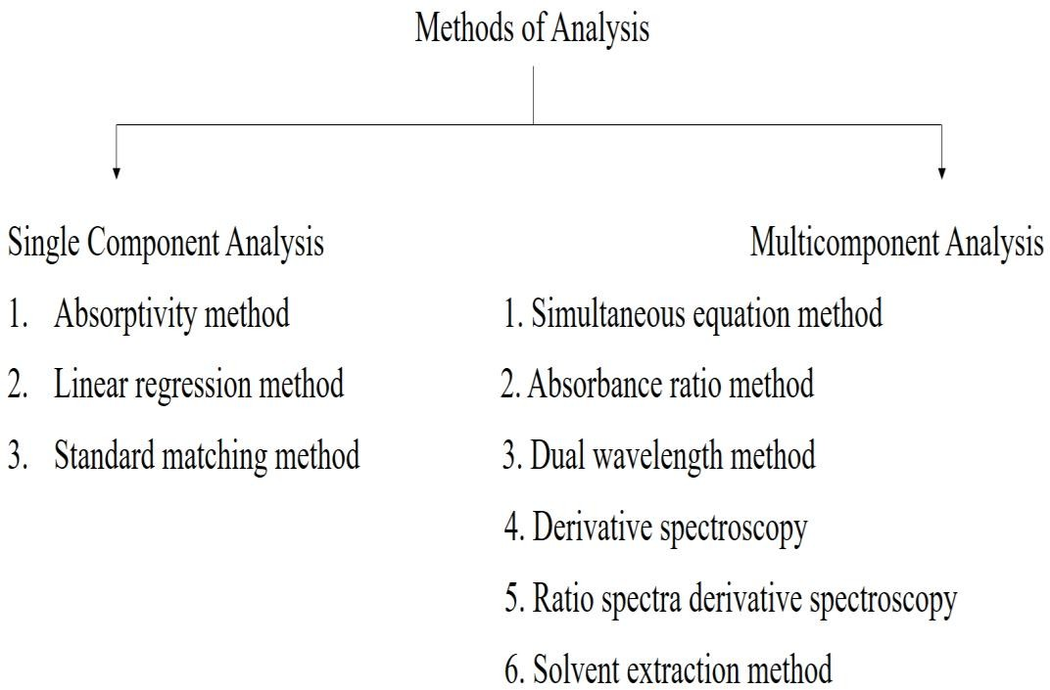

Figure 2: Overview of different methods of analysis

Multicomponent Analysis method:
Fact behind most of the spectroscopic methods which is used for the determination of multicomponent sample is the property that,
On most of the wavelength:
- Solution’s total absorbance is composed of the sum of individual component’s absorbance.
- Final absorbance = difference of solution’s total absorbance in reference cell and solution’s total absorbance in sample cell.
Different types of Spectrophotometric techniques are used for the analysis of multicomponent sample.

Vierordt’s method (Simultaneous Equation Method):
In case of sample having two absorbing drugs (suppose X and Y) individual of them gives absorbance on λmax of another (Figure 2, λ1 and λ2), determination of both drugs is possible with the help of simultaneous equation method (Vierordt’s method).
Cy = (A1 aX2 - A2 aX1) / (aY1 aX2 - aY2 aX1) Cx = (A2 aY1 – A1 aY2) / (aY1 aX2 - aY2 aX1)
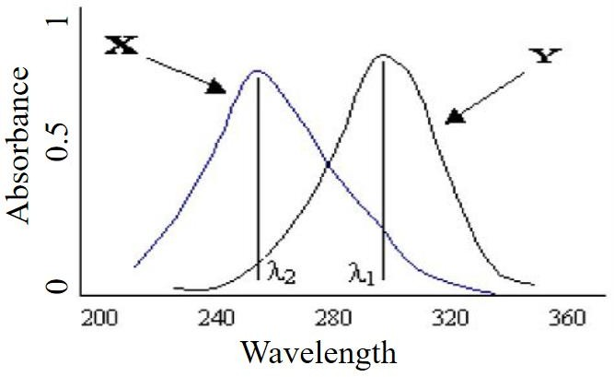

Figure 3: Overview of simultaneous equation method
Where,
λ1 = λmax of component X λ2 = λmax of component Y

aX1 = absorptivity of component X at λ1.
aX2 = absorptivity of component X at λ2. aY1 = absorptivity of component Y at λ1.
aY2 = absorptivity of component Y at λ2.
A1 = absorbance of diluted sample of mixture at λ1. A2 = absorbance of diluted sample of mixture at λ2. Cx = concentration of X.
Cy = concentration of Y. The criteria are as follows:
- For the precise determination of Y and X the respectively ratios (A2/A1) / (aX2/aX1) and (aY2/aY1) / (A2/A1) should lie outside the range of 0.1-2.0. The condition when λmax of the two components are reasonably dissimilar is able to satisfy these criteria.
- Two components do not interact chemically, thereby negating the initial assumption that the total absorbance is the sum of the individual absorbance.

Q-Absorbance Method (Absorbance Ratio Method):
If substance follows Beer's law at all wavelength, ‘the value which indicates the ratio of measured absorbance at any of the two wavelengths is a persistent and it does not depend on concentration or path length’ is the property which forms the basis of this Q-Absorbance method for multicomponent sample. For example, the same absorbance ratio A1/A2 is obtained by two individual dilution of the similar substance. Concentration of two drugs in the mixture can be calculated using following equations:

CX = [(QM - QY) / (QX -QY)] × A1/aX1 CY = (A1/aX1) – CX

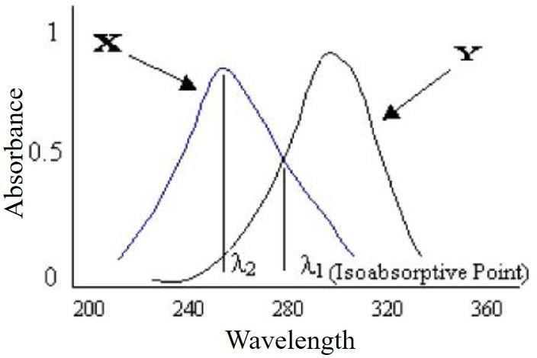

Where,

Where,

Figure 4: Overview of Q-Absorbance method

QM = A2 / A1, QX = aX2 / aX1 QY = aY2/aY1.

A1 = absorbance of mixture at iso absorptive point.
A2 = absorbance of mixture at λmax of one drug component. aX1 and aY1 = absorptivities of drug X and drug Y respectively at iso absorptive point.
aX2 and aY2 = absorptivities of drug X and drug Y respectively at λmax of one drug component.
In the USP, this ratio is referred to as Q value.

Dual Wavelength Method:
Dual wavelength method of analysis for multicomponent sample is used to calculate concentration of compound of interest from the sample mixture. The sample mixture is made up of both that is compound of interest as well as undesirable interfering compound. Concentration of compound of interest can be carried out with the help of taking difference of 2 points on the spectra of sample mixture, which is proportional to the compound of interest, and independent of undesirable interfering compound.

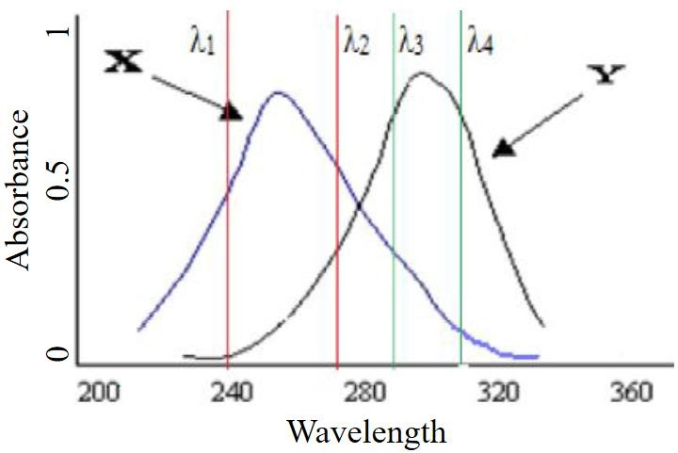

Figure 5: Overview of Dual wavelength method
Essential requirement for dual wavelength method:

        - Selection of two wavelengths with taking care that the interfering component gives the same absorbance while the component of interest gives remarkable difference of absorbance with concentration.

Estimation of drug:

        - Graph of difference in the absorbance VS concentration is plotted and from the regression equation amount of drugs present in the mixture can be calculated.

Derivative Spectroscopy:
Transformation of a standard spectra to its first derivative, second derivative or higher derivative spectra provides the base for derivative spectroscopy.
First derivative D1 spectra = Plot of the slope of fundamental spectra versus wavelength OR plot of the rate of change in absorbance with wavelength against wavelength OR a plot of dA/dλ vs. λ.

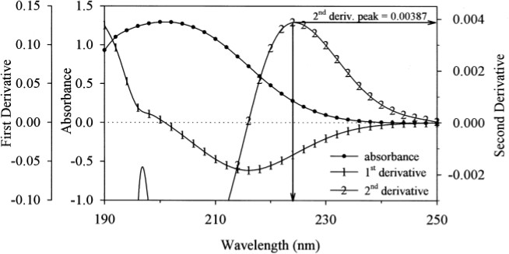

Figure 6: Overview of Derivative spectroscopy method
Second derivative D2 spectra = Plot of the curvature of the D0 spectrum against wavelength OR a plot of d2A/dλ2 vs. λ. Likewise, third and fourth derivatives are prepared as per requirements. For single drug molecule, we can use simple UV method which involves use of Double Beam Spectrophotometer.

Ratio spectra derivative spectroscopy:
This method of analysis for estimation of multicomponent sample have mathematical base that if the spectra of mixture containing two components X and Y is divided by spectra of a solution of say X (solution of X = divisor solution), the spectra which is obtained is the ratio spectra of Y. If determination of the first derivative of this ratio spectra is performed, the amplitude generated by the signals are directly proportional to the concentration of Y in the mixture solution.
By following the same procedure but this time, use solution of Y as a divisor solution so it will provide data for determination of concentration of X in the mixture solution.
Merits of derivative ratio spectra spectroscopy:
- Uncomplicated measurement on separate peaks.
- Analytical signals having higher values.

- It does not require to work on zero crossing point (ZCP).

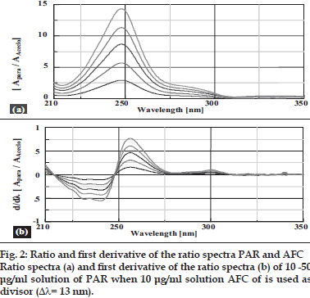

Figure 7: Overview of ratio spectra derivative spectroscopy
      - Solvent extraction method:
In this method of analysis, measurement of each drug in combination is likely to be carried out with the help of separation of individual drug. This process of separation is generally based on selective solubility of drug and followed by spectrophotometric measurement. If other absorbing substance creates interference in large amount, separation of absorbing substance which causes interference from analyte is possible with the help of solvent extraction method. This method of analysis for multicomponent sample is extremely suitable for analysis of acidic and basic drug, solvent partitioning behavior of them can be determined with the help of their ionization state.

Partial Least Square (PLS) Method[10-32]

History of partial least square:
Herman wold was developed partial least square model in 1960’s for the use of econometrical technique, but some of its most eager proponents (including wold’s son svante) are chemical engineers and chemometricians. Partial least square has been applied to monitoring and controlling industrial processes, and it can be easily having hundreds of controllable variables and dozens of outputs. These are all about spectrometric calibration.

Introduction of partial least square:
In the field of chemometrics, PLS has received great amount of attention due to its importance. The algorithm is used as a standard tool for processing a wide spectrum of chemical data problems. Due to its great success it possesses a wide variety of application in other scientific areas including bioinformatics, food search, medicine, pharmacology, social science, physiology and in other work areas.
Generally, PLS creates orthogonal score vectors in its general form, which is also known as latest vectors or components. This vector is created by maximizing the covariance between different sets of variables. In this topic, PLS dealing with two blocks of variables is considered, although the PLS extension to model relations among a higher number of sets exist. PLS is somewhat related to canonical correlation analysis (CCA), in which latent vector with maximal correlation are extracted. Now, to extract this latent vectors, various PLS techniques are used, and each of them gives rise to a variant of PLS.
PLS can be naturally extended in the form of regression problems. In which the prediction and predicted variables are each considered as a block of variables. After that PLS extract the score vectors which can serve as a representation of new predictor and on this new predictor, it regresses the response variables. The natural asymmetry between predictor and response variables is reflected in such a way in which the score vectors are computed. These variants are known as PLS1 (one response variable) and PLS2 (at least two response variable). PLS is considered as

a rigorous statistical model, and its use is overlooked by statisticians. Interest in the statistical properties of PLS has been risen from last few years. PLS is also related to other regression methods like principal component regression (PCR) and ridged regression (RR). So, these all methods fall under a unique approach which is known as continuum regression. The effectiveness of PLS can be theoretically studied in terms of its variance and its shrinkage properties. In several simulation studies, the performance of PLS can be investigated.
PLS can be also be applied to classification problems by encoding the class membership in an appropriate indicator matrix. PLS possess a close connection for classification to fisher discriminant analysis (FDA). As similar to PCA, the PLS can be as a discrimination tool and dimension reduction method. An appropriate classifier can be applied after relevant latent vectors are extracted.
At last, the powerful machinery of kernel – based learning can be applied to PLS. these kernel methods are an elegant way of extending linear data analysis tools to non – linear problems.

Partial least square:
Consider the general setting of a linear PLS algorithm to model the relation between two data sets (blocks of variables). Denote by XR N an N-dimensional space of variables representing the first block and similarly by YRM a space representing the second block of variables. PLS models the relations between these two blocks by means of score vectors. After observing n data samples from each block of variables, PLS decomposes the (n × N) matrix of zero-mean variables X and the (n
× M) matrix of zero-mean variables Y into the form, X = TPT +E
Y = UQT +F
Where the T, U are (n × p) matrices of the p extracted score vectors (components, latent vectors), the (N × p) matrix P and the (M × p) matrix Q represent matrices of loadings and the (n × N) matrix E and the (n × M) matrix F are the matrices of residuals. The PLS method, which in its classical form is based on the nonlinear

iterative partial least squares (NIPALS) algorithm, finds weight vectors w, c such that,
[cov (t, u)]² = [cov (Xw, Yc)]2 = max|r|=|s|=1[cov (Xr, Ys)]²

where cov (t, u) =t^{T}u/n denotes the sample covariance between the score vectors t and u. The NIPALS algorithm starts with random initialization of the Y-space score vector u and repeats a sequence of the following steps until convergence.
- 𝑊 = 𝑋𝑇𝑢(𝑢𝑇𝑢)
- ‖𝑊‖ → 1
- t = Xw
- 𝑐 = 𝑌𝑡𝑇⁄(𝑡𝑇𝑡)
- ‖𝐶‖ → 1
- u = Yc
Note that u = y if M = 1, that is, Y is a one-dimensional vector that we denote by y.

For a data analysis and regression by PLS, many software available, that are XLSTAT, camo, Unscrambler®, smartPLS, SPSS, WarpPLS, LISRET, etc.

Introduction to chromatography as a separation and quantification technique:[1, 4, 6, 7, 33-36]
Chromatography is the branch of science which performs separation of components depending upon the composition or structural difference. Majorly separation dependent on difference in interaction between the components on the surface. One might look at separation of components in mobile phase. Assume that out of two, one component has similar affection with surface and eluent and other has massive affection. When they are injected, they move along the column by solvent flow. Molecules of the 1st component will interact with the surface and retained as like solvent. So, we can say that it will travel along with solvent.
Due to higher interaction of another component, it will remain on surface. So, it will move through the column at slower rate. Usually small volumes are injected. During separation, the eluent band becomes broad due to the irregular paths around the beads, longitudinal diffusion, and other factors. Combination of all the factors leads to band broadening. In general, broader peak can be obtained if components are retained longer on to column.
Effectiveness of separation depends on retention of component, band broadening and other kinetic modules. Separation efficiency also depends on properties of column packing and type of packing materials. So, retention totally depends on surface interaction and available surface.

High performance liquid chromatography as a choice of method for analysis:
HPLC can analyze number of multi component formulations because of its virtues like ease of automation, fast, specificity, accuracy, precision. It eliminates complex separation procedures.
Its advantages are as follows:
- High Speed (Majority of separation can be completed in less than 20 minutes).
- Implacable sensitivity (Due to wide range of available detectors).
- Better resolution (wide availability of interacting surfaces).

- Reclaimable columns (multiple analysis can be performed on single column after giving suitable regenerations).
- Low volatile substance can be easily handled.
- Sample handling and recovery are quite easy.
- Automation in the instruments lead to fast analysis time and less manpower.
- Unique property of being reproducible and precise.
- Automatic integration is available for Quantitation.
- On larger scale it can modified to preparative operations.

Modes and types of HPLC
Various type of HPLC is originated depending upon type of interaction that is taking place between stationary phase and mobile phase. Depending upon the principle of interaction various types of chromatographic technique for separation and quantification have been originated which are as follows:
- Normal phase chromatography
- Reverse phase chromatography
- Size exclusion chromatography
- Ion-Exchange chromatography
- Ion pair chromatography
- Chiral chromatography
When we discuss about the mode in chromatography, it is mainly based on which type of mobile phase and stationary phase is supposed to be used in the process of separation. So chromatographic modes include either reverse phase or normal phase. Depending upon the polarity of surface two modes are available. In Normal- phase mode, interacting phase is polar while eluent is non-polar (such as THF or n- hexane). So, surface can retain polar component on the surface than less polar materials. In reverse phase mode the eluent is a polar liquid and stationary phase is hydrophobic (i.e. mixtures of Acetonitrile or methanol and water).

Here the more hydrophobic component is retained longer. About 90% of all chromatographic applications are comes under these 2 types of chromatographic mode. In all variants of HPLC, polarity of eluent contributes the lead role.

Normal Phase Chromatography:
- Stationary phase: Polar,
- Mobile phase: Non-polar
In this mode of chromatography ‘the stationary phase which is used in the process of separation is more polar compare to mobile phase which is supposed to be utilized’. Generally, silica based stationary phase is widely used for preparative HPLC. Requirement of hydrophilic surface can be fulfilled by polarity of underlying silyl ether and silanol.
Tiny silica particles are mainly used for column packing, and non-polar solvent is utilized. During the process of separation, polar compounds from the sample mixture will interact more extensively to the polar silica compare to non-polar compounds. Therefore, the non-polar compounds from the sample mixture runs more quickly through the column.

Reverse Phase Chromatography:
- Stationary phase: Non-polar,
- Mobile phase: Polar
Reversed phase chromatography is ‘a process of elution in which polarity of the mobile phase is significantly high than that of the stationary phase’. This mode of chromatography utilizes hydrophobic (non-polar) column packing with Octyl or Octa Decyl functional group which are bonded to silica gel and uses polar solvent as mobile phase.
In this case, polar molecules in the mixture are strongly attracted towards the polar solvent. Not so much attraction will take place between the polar molecules of drug in the solution and the hydrophobic that is non-polar stationary phase. So the polar molecules in the mixture will therefore be eluted faster. Therefore, elution of polar molecules from the mixture will take place at higher rate compare to non-polar molecules.

Non-polar molecules in the mixture will strongly attracted to the hydrocarbon groups by the force called Van der Waals dispersion force. They have less solubility in the solvent due to their requirement to break hydrogen bonds. So, spending more time in the column will decrease their rate of elution from the column. Octa Decyl Silane or C4, C8, C18, are the different types of columns which are used.

Types of elution techniques in HPLC
The available elution modes are namely isocratic and gradient. In the isocratic mode, mobile phase is maintained at a constant composition throughout the separation process. In gradient mode, composition of mobile phase is changed during the separation process. Out of these two modes, reverse phase mode is the most preferred mode in analysis of compounds from pharmaceutical, biological, food and chemical compounds.
In general terms we can say that,
- Isocratic mode: Same mobile phase composition is used throughout the process of separation. The same polarity or elution strength is maintained throughout process.
- Gradient mode: A mobile phase composition of lower polarity or elution strength is used following by gradually increasing the polarity or elution strength.

Principle of High-performance liquid chromatography
- The principle behind the separation process in normal phase and reverse phase is adsorption, partition toward the stationary phase.
- In adsorption movement of a sample mixture of different components which is introduced into a HPLC column is based upon relative affinities of them towards the stationary phase.
- Components having less affinity for stationary phase are supposed to be travel at faster rate compare to components with more affinity towards the stationary phase.
- In partition component which is more soluble in stationary phase travel slower and components which is more solubility in mobile phase travels fast.

Instrumentation of HPLC
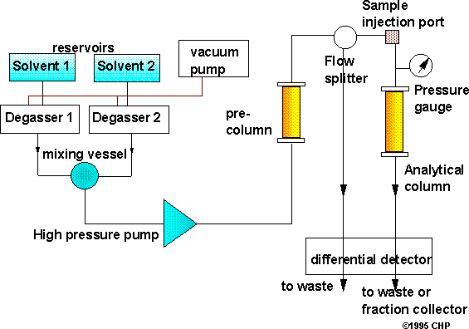

Figure 8: Instrumentation of HPLC
The basic instrument of HPLC includes following compartments:
- Pumps
- Solvent degasser and mixing vessel
- Sample injection port
- Pre-column (Guard column)
- Analytical column
- Detector
- Read out system

Pumps:
Solvent / mobile phases used must be passed through the column at high pressure at about 1000 – 3000 psi. Because of particle size of mobile phase is few (5µ – 10 µ), the resistance to solvent flow is high. There are two type of pumps are available. Mechanical pump operates with constant flow rate and uses a sapphire piston. Pneumatic pump is operating with constant pressure and high compressed gas.

Solvent degasser and mixing vessel:
Organic solvents are able to solubilize several gases. Probability for formation of gas bubbles is enhanced if solvents are pumped under higher pressure. These bubbles create interference with process of separation, shape of peak and steady baseline.
Mixing vessels/units are used for mixing of solvents in different proportions and pass through the column. Helium is used as solvent degasser for low mixing chamber. High mixing chambers does not require helium as solvent degasser. In an isocratic separation, preparation of mobile phase is done by using pure solvent/mixtures of solvent. Gradient controller is utilized, when process of separation is supposed to use two or more solvent pumps.
Vacuum filtration, Helium purging and ultra-sonication are basically used as degassing techniques.

Injector in HPLC:
Septum injectors: They Inject sample through a rubber septum.
Stop flow (one line): Flow of mobile phase is terminated for a while and during this time sample injection will take place.
Loop value (Rheodyne injector): It has a fixed volume loop like 20µl or 50 µl or more.
Nowadays auto samplers are widely used which has greater accuracy and linearity.

Pre-column (Guard column):
Pre-column having very little quantity of adsorbent and it contributes to improve the life of the analytical column. It also plays an important role in elimination of particulate matter.

Analytical Column:
Analytical column plays an important role or we can say a lead role in HPLC techniques, which determines the efficiency of separation. Column can be made up of either stainless still or glass.
Polyethylene or PEEK (poly ether ketone) can also be utilized for column manufacturing.
- Column length use: 5 cm – 30 cm.
- Column diameter use: 2 mm – 50 mm.
- Particle size use: 1µm - 20µm
- Nature of particles use: Globular equally sized, penetrable materials are used.

Detectors:
- UV- detector
- Refractive index detector
- Flourimetric detector
- Conductivity detector
- Amperometric detector
- Photodiode array detector (PDA detector)

Read out system:
Read out system or recorders are used to record response which obtained from detectors. They record all peaks and baseline with time. Retention time for all peak can be found but area of individual peak not known. Integrators are improved version of recorder with some data.

Integrators can record individual peak with:
- Retention time
- Height & width of peak
- Area of peak
- % of peak etc.
Nowadays printers are used for the recording and controlling for several programs.

Introduction to system suitability parameters
USP chromatography chapter says that “one of the most essential part of separation methods are SSTs”. They confirm that the given developed system will quantify and separate analyte with adequate reproducibility and precision.

Table 1-1: System suitability parameters in HPLC

System suitability parameters and Limits
SSTs | Stated Limits
Capacity Factor (k’) | k’ > 2.0.
Repeatability | For N > 5, RSD ≤ 1 % is preferable.
Relative  retention | Not essential (If Rs is mentioned)
Resolution  (Rs) | Rs more than 2 between two closest  eluting peaks
Tailing factor (T) | T ≤ 2 is preferable
Theoretical Plates (N) | N> 2000.

Resolution:
It describes separation ability of the chromatographic system to separate the present components from given matrix. One can say that, Rs between neighboring peaks

the ratio of the difference between maxima of two eluting peak in minutes to the half sum of their respective peak width.
Following formula can be applied for calculation of resolution.
𝐭𝐑𝟏 − 𝐭𝐑𝟐
𝐑𝐬 = 𝟏
𝟐 (𝐖𝟏 + 𝐖𝟐)
Where, tR1 and tR2 are retention time of eluting component in minutes while W1 and W2 are peak width of corresponding components in minutes.

Column efficiency/ Number of theoretical Plates:
Column efficiency can be estimated by number of theoretical plates for a given column. It also gives idea of band broadening. Ideal value of N¹ for a given column ranges from 5,000 to 1, 00,000 plates/meter. It can be determined in following way.

tR² N = 16 W2
A reduction in a measure of column performance can due to,
- History and life span of the column.
- External sources of band broadening (improper working of injector or damaged column tubing).
- Inadequate detector setting.
- Change in pump performance (i.e. flow rate and temperature).

Peak Asymmetry factor / tailing Factor:
Tailing factor or Asymmetry factor, As, is one of the most important parameters for measuring column performance. Value of 0.9 to 1.1 should be achievable for a perfectly packed column. Following formula can be used to calculate As.
𝑏

Where, a and b are half peak widths.
𝐴𝑠 =
𝑎

Capacity Factor:

When reduced volume is divided by dead volume, it gives measure of capacity factor. It gives idea about the handling of analyte in column during elution process Following formula can be used to calculate capacity factor:
K′ = V1 − V0
V0
Where, V1= retention Volume at apex of peak and V0 =void volume. The Ideal value of k’ ranges from 2-10.

Introduction to Analytical method validation[37]
Analytical method validation describes the potential of a specific method to give test result consistently and continuously as per predetermined specifications. Analytical method validation is a part that has been included in many pharmacopoeias like United States Pharmacopoeia, British Pharmacopoeia and as a separate guideline in International conference on harmonization. The WHO has given principles as, Validation of analytical procedures used in the examination of pharmaceutical materials.
’This guideline had been appeared in 1992 when 32nd report of WHO committee was issued. The section is becoming of importance as it sets standards necessary for appropriate method development and there by ensure a quality product. ICH has issued guideline for quality which are adopted by nations like US, Japan and European countries.
Two guidelines are available under title of- ‘Q2A: Text on validation of Analytical procedures’ and ‘Q2B: validation of Analytical Procedures Methodology’, USP (2004) has a section describing requirements of validation of analytical methods. This guideline has not been included in Indian Pharmacopoeia.

Method validation is documented evidence that a particular method is performing for intended purpose according predetermined specifications one can adjudge consistency and reliability of method from results of validation.

Range and Linearity:
It is potential of method to produce results that are directly proportional to the concentration of component in given samples. It is demonstrated by particular mathematical transformations.
- It may be directly performed on the substance under examination and/or using standard and suitably diluting by proposed method.
- It can be performed by determining at least 5 injections in series of standards. Concentrations may be 80–120 percent of the proposed range.
- The response of sample to the concentration must be demonstrated by mathematical equation
- A significant zero intercept must be obtained when linear regression method is applied and if it is not obtained then one has to prove that there is no significant effect on accuracy.
One other approach can be utilized that is response factor, which can be obtained by dividing response with corresponding concentration that will give relative response. A graph of relative response vs concentration is plotted on a logarithmic scale. So, the horizontal line obtained must ne linear over the entire range. Usually negative deviation occurs at higher concentrations. A horizontal line is drawn parallel to x axis on the graph corresponding, 95 to 105 percent of the horizontal line. The response is linear to concentration till the point where the horizontal line intersects the 95 percent line.
It is the interval of concentration between which Quantitation can be performed with adequate accuracy and precision and method is linear. The range of analytical method is expressed in the same units (e.g., PPM or %).

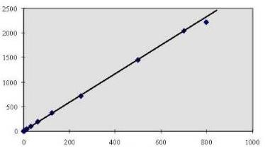

Figure 9: Diagrammatical representation of Linearity
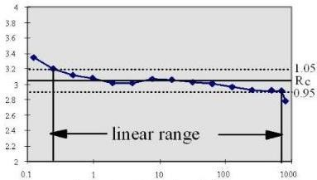

Figure 10: Diagrammatical representation of Range

Reproducibility and Precision:

It is defined as degree of closeness among the test results when method is performed on several samplings of a same sample. Relative standard deviation or C.V. can be used to express it. It can be further divided in to reproducibility, repeatability and intermediate precision
Repeatability is potential of an analytical method to generate similar test results when method is carried out in similar environment by same operator over a short

period of time. It can be expressed as R.S.D. here minimum 3 concentrations are taken and analysis is performed on each for at least 6 time and R.S.D. is calculated. At least 6 replications must be analyzed covering 100 % of target concentration or
9 repetitions covering entire linear range. (i.e. 3 replications for each of 3 concentrations)
The reproducibility is potential of an analytical method to generate similar test results when method is applied on homogenous sample in different conditions and by different analyst. Operation conditions are different but difference is still within the limits. It is quite important validation parameter if method has to be operated in different conditions.

Accuracy and Recovery:
It potential of method to produce results near to the true or standard value (Standard value may be reference value given in official compendia).
Selected concentration for accuracy studies must cover entire concentration range (i.e. one may the lowest concentration, one may the middle and one may be the last of range).
Accuracy is performed by performing recovery studies by spiking in 2 ways:
- Spiking of sample with standard (in case placebo are not available).
- Spiking of placebo with standard.
It can be performed at different level like 50, 100 and 150 % of test concentration or 80, 100, 120% of test concentration.

Limit of Quantification and Limit of Detection:
It refers to the ability of analytical method to detect analyte in presence of matrix with adequate accuracy and precision. Method can detect the analyte but may not be able to perform quantification. One might be confused between the sensitivity of method and LOD. Sensitivity may differentiate small difference in concentrations. One can say that it is the slope of regression line.

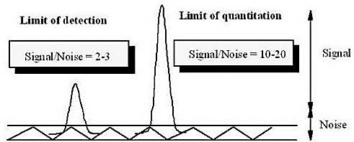

Figure 11: General representation of LOD and LOQ

Following methods are available other than signal to noise ratio that are as follows:

- Visual determination: it can be determined by manually injecting lowest known concentration which can be detected but not quantified by mathematical transformations.
- Standard deviation of response based on standard deviation of blank: it can be measured by analyzing number of blank samples and obtaining S.D of these blank responses. This method gives idea about the ability of a method to give response other than analyte.
- Utilizing slope of regression line for measuring S.D. of response: here one can measure the S.D. of regression line of a given calibration curve or can utilize
S.D. of intercept.
- It can be also calculated by mathematical equations that are explained below:
𝜎
𝐿𝑖𝑚𝑖𝑡 𝑜𝑓 𝐷𝑒𝑡𝑒𝑐𝑡𝑖𝑜𝑛 = 3.3 ×
𝑆
𝜎
𝐿𝑖𝑚𝑖𝑡 𝑜𝑓 𝑄𝑢𝑎𝑛𝑡𝑖𝑓𝑖𝑐𝑎𝑡𝑖𝑜𝑛 = 10 ×
𝑆

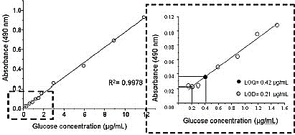

Figure 12: Regression line method for determination of LOD and LOQ

Ruggedness:
Exact definition of ruggedness has not been included in guidelines but it has similar interpretation as reproducibility that is same response obtained under different environment (i.e. different labs, environmental conditions, equipment and or analyst). So, one can say that ruggedness is the degree of reproducibility under normal variable conditions.
It gives idea of reproducibility of obtained response under routine, expected analytical conditions varying in different lab as well as different analyst. For performing ruggedness of method homogenous sample aliquots are estimated in different condition and degree of difference can be estimated by T-test.

Robustness:
It is potential of a method that it should not affected by small but deliberate changes in operational conditions but still these changes are within the range. Influences of these changes are measured on response obtained by the method. By performing robustness one can determine that weather there is a need of revalidation or not. Various method parameter that can be changed are like flow rate, mobile phase

composition, pH of mobile phase, detection wavelength. This change can be within the limits (i.e. 2-5% of original value)
One may identify the critical method parameter which can actually identify the susceptibility of method towards the changes and must be documented as per ICH guidelines. However, it is not a part required for registration.

Solvent stability:

Numerous examples show that certain molecules in solution readily decompose prior to analysis. They might decompose at various stages of treatment like sample preparation, solvent extraction, or sample storage (i.e. in automatic samplers or during preservation in refrigerator). Under such conditions one must assess the stability of standard and sample. One must assess the stability of sample and standard under such conditions for at least 48 hours. For determining stability of standard and sample one must analyze same sample at small intervals over 48 hours.
R.S.D is calculated for test response obtained at various intervals and it must not above at least 20 % from system precision.

Data elements required for analytical method validation
For determination of pharmaceutical material there are various analytical methods. But all above mentioned validation parameter are not considered for a particular method. Analytical methods are classified in different categories which are as follows:

Category I:
Includes quantification methods of active substance from matrix or major components like preservatives from finished dosage form

Category II:
Includes quantification methods of impurities either from matrix or quantification of degradation products from finished dosage from.

Category III:
Methods which can determine or present performance of the system (example: release of drug, dissolution).

Category IV:
Test for identification.

Table 1-2: Consideration for analytical method validation

Analytical Task | Identification | Impurity and Quantitative | Impurity and Qualitative | Assay Category 3
Accuracy | NO | NO | YES | YES
Precision
Repeatability | NO | YES | NO | YES
Intermediate Precision | NO | YES | NO | YES
Reproducibility | NO | NO | NO | NO
Specificity | YES | YES | YES | YES
Limit of detection | NO | NO | YES | NO
Limit of  Quantification | NO | YES | NO | NO
Linearity | NO | YES | NO | YES
Range | NO | YES | NO | YES

Introduction to Drug profile

    - Introduction of olopatadine hydrochloride
    - Table 1-3 Introduction of Diltiazem malate

 | DRUG INFORMATION
Therapeutic category | Mast cell stabilizers
Therapeutic indication | Olopatadine is indicated for the symptomatic treatment of ocular itching associated with allergic conjunctivitis as ophthalmic solution
Mechanism of action  Chemical Structure | Blocking the effects of histamine  It is a structural analog of doxepin, which has a minimal anti-allergic activity. 10 Olopatadine works by blocking the effects of histamine, which is a primary inflammatory mediator that causes inflammatory and allergic reactions  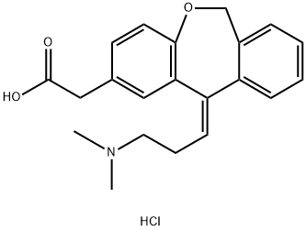
 | NOMENCLATURE
Chemical name | (Z)-2-(11-(3-(dimethylamino)propylidene)-6,11-dihydrodibenzo[b,e]oxepin-2-yl)acetic acid hydrochloride
Empirical formula | C21H24ClNO3
Molecular weight  (gm/mol) | 373.88
 | PHYSICOCHEMICAL PROPERTIES
Appearance | White powder
Solubility | Freely soluble in Water

    - Drug profile of Enalapril malate[39]

 | DRUG INFORMATION
Therapeutic category | Angiotensin converting enzyme inhibitor.
Therapeutic indication | Hypertension, heart failure, lowering high blood pressure, prevent strokes, heart attack and kidney problem.
Mechanism of action  Structure | Hydrolysis of enalapril malate it covert into ACE inhibitor and ACE is a peptidyl dipeptidase that catalyze the conversion of angiotensin I to the vasoconstrictor substance, angiotensin II.  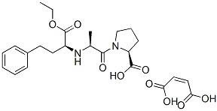
 | Nomenclature
Chemical name | (Z)-but-2-enedioic acid;(2S)-1-[(2S)-2-[[(2S)-1- ethoxy-1-oxo-4phenylbutan-2-yl] amino] propanoyl] pyrrolidine-2-carboxylic acid
Empirical formula | C24H32O2N9
Molecular weight  (gm/mol) | 492.525
CAS number | 76095-16-4
Approval status | Approved in IP 2010, USP

PHYSICOCHEMICAL PROPERTIES
Appearance | It is white Crystalline  powder
Solubility | Alcohol(0.08gm/ml), methanol(0.20gm/ml),  water (0.025)
Melting point | 143-144.5ºC

    - Marketed Formulation Table 1-4 Marketed Formulation

Proprietary Name | Teczem
Marketed by | Hoechst Marion Roussel
Content | Enalapril malate…….5mg  Diltiazem malate……180mg
Indication | Anti – hypertension.

Review of literature
  - Review of analytical method for diltiazem malate and enalapril malate: Table 2-1 official method for Diltiazem malate

Official method for Diltiazem malate
Sr.no. | Drug | Method | matrix | Stationary phase | Analytical condition | Detection condition | Reference
1 | Diltiazem | RP – HPLC | Bulk | Stainless steel column 30 cm × 3.9 mm, packed with octadecyl silyl silica gel (5µm) | 0.116%w/v of d – 10 - camphosulphonic acid in 0.1 M sodium acetate  pH = 6.2, flowrate = 1.6ml/min, 10µl loop injector | Spectrophotometer set at 240nm | [40]

Table 2-2 Nonofficial method for diltiazem malate

Nonofficial method for diltiazem malate
Sr.  no. | Drug | Method | Matrix | Stationary phase | Analytical condition | Detection condition | Reference
2 | Diltiazem and statin | RP-HPLC | Human serum | Hiber®, 250-  4.6 RP-18  Column | ACN: water (85:15v/v)  pH=2.6±0.02),  flowrate=1.0mL/min | UV visible detection at 230nm | [41]
3 | Diltiazem hydrochloride and mexiletine hydrochloride | UV  spectrophotometric method (simultaneous equation method) | Bulk | - | Concentration range  = 3.0-8.0 µg/ml  (diltiazem), 50-  100µg/ml (mexiletine) |  | [42]
4 | Diltiazem hydrochloride and it’s  metabolized des acetyl diltiazem hydrochloride | HPLC | Bulk | Microbonapack C18 column, (4.6×250nm) | Acetate buffer: ACN (650:350v/v);  flowrate = 1.0mL/min | UV detection at 240nm | [43]
5 | Diltiazem hydrochloride and lovastatin | RP-HPLC | Tablet | Kromasil C18 column (300mm×4mm i.d., 10µm) | Methanol: water (90  :10v/v), flowrate = 1mL/min | UV detection at 237nm | [44]

6 | Diltiazem and quinolones | RP-HPLC | Bulk  Formulation  Human serum | Hiber®, RP-18 column | ACN: methanol: water (30:20:50v/v)  pH=3.6 | UV detection at 237nm | [45]
7 | Diltiazem, metformin, pioglitazone and rosiglitazone | RP-HPLC | Human serum | Hiber®, 250-  4.6, RP-18  column | ACN: methanol: water (30:20:50v/v)  pH=2.59±0.02 | UV detection at 230nm | [46]

Table 2-3 Official method for enalapril maleate

Official method for enalapril malate
Sr.  no. | Drug | Method | Matrix | Stationary phase | Analytical condition | Detection condition | Reference
8 | Enalapril malate | HPLC | Bulk | Stainless steel column 25 cm ×  4.6 mm (5 to 10 µm) | Phosphate buffer: ACN (4:1), flowrate = 1mL/min | UV detection at 210nm | [40]
9 | Enalapril malate | HPLC | Bulk | 4.1mm × 15cm column | Mobile phase= solution A and solution B, flowrate= 1.5mL/min | UV detection at 215nm | [40]

10 | Enalapril malate | HPLC | Tablet | 4.6nm × 25cm column (5µm) | Buffer: ACN (75:25),  flowrate= 2mL/min | UV detection at 215nm | [47]
11 | Enalapril malate and hydrochlorothiazide | HPLC | Tablet | 4.6nm × 20 cm column (10µm) | Water: ACN: buffer (34:15:1), flowrate= 2ml/min | UV detection at 215nm | [47]

Table 2-4 Nonofficial method for enalapril maleate

Nonofficial method for enalapril maleate
Sr.  no. | Drug | Method | Matrix | Stationary phase | Analytical condition | Detection condition | Reference
12 | Enalapril malate and metoprolol | RP-HPLC | Tablet | Kromosil C18 (250×4.6mm, 5µm) | Orthophosphoric acid buffer: methanol (65:35v/v), pH=2.45,  flowrate=1.0mL/min. | UV  detection at 254nm | [48]
13 | Enalapril malate and ramipril | RP-HPLC | Tablet Bulk | Oyster BDS C18 column (250×4.6mm, 5µm) | Buffer A: buffer B (50:50), Ph=2.6±0.1,  Flowrate=1.0mL/min | UV  detection at 208nm | [48]
14 | Enalapril malate, hydrochlorthiazide and paracetamol | RP-HPLC | Tablet | C18 RP-column (Hi- Q 250 × 4.6mm i.d.,  5µm | ACN: water  (25:75v/v),  flowrate=1.2mL/min | UV  detection at 220nm | [49]
15 | Enalapril malate and hydrochlorthiazide | RP-HPLC | Tablet | C18 (ODS UG  column, 250mm×4.6mm) | Acetate buffer:  methanol: ACN (60:20:20v/v), Ph=5,  flowrate = 0.8mL/min | UV  detection at 232nm | [50]

16 | Enalapril malate and amlodipine besylate | RP-HPLC | Tablet | Phenomene X C18 5µm,250mm×4.6mm.  i.d. column | Methanol: ACN: water (40:50:10v/v),  flowrate=1.0mL/min | PDA  detection | [48]
17 | Enalapril malate and chlorthalidone | RP-HPLC | Synthetic mixture  Bulk | Hypersil BDS C18 (250×4.6mm, 5µm) | Phosphate buffer: ACN: methanol (65:25:10v/v),  flowrate=1.0mL/min | UV  detection at 210nm | [51]
18 | Enalapril malate and lercanidipine HCL | RP-HPLC | Synthetic mixture  Synthetic tablet | Hiber® C18, pre- packed column | ACN: methanol: water: orthophoric acid (35:35:30:0.2), pH =  3.0,  Flowrate=1.0mL/min | UV  detection at 210nm | [52]

  - Summary of PSAR report Table 2-5 Summary of PSAR report

Sr.  No. | Patent Application Number | Title of Patent
1. | RU20090123618A | Method for quantitative determination of enalapril
2. | US08276678 | Stable solid pharmaceutical compositions containing enalapril malate
3. | US20010007687A1 | Diltiazem controlled release formulation and method of manufacture
4. | CN20081201228 | Method for quantitatively screening 242 kinds of compounds by liquid phase chromatography – mass spectra at the same times
5. | US07195151 | Pharmaceutical composition containing diltiazem and angiotensin – converting enzyme inhibitor

Looking at above 05 patents, your selected dissertation project is novel up to what extent? Novelty grade:
- >90%, - 50 to 90%, - <50%, -Not novel

From above five patents, it is studied that the pharmaceutical composition of diltiazem and enalapril is useful for the treatment of hypertension and cardiac/coronary insufficiency and it is also observed that the effect of combine administration of diltiazem and enalapril is greater than the sum of the individual anti-hypertensive effect upon the separate administration of diltiazem and enalapril alone. The other patent gives idea about the quantitative determination of enalapril in the production process, which relates to the field of analytical chemistry and this method provides high detection sensitivity. One of patent describes a qualitative determination of diltiazem and other compounds by using liquid chromatography – mass spectrometry method (LC/MS). Other remaining patent describes the pharmaceutical composition and its method of manufacture for enalapril and diltiazem so, from above patent it is concluded that there is no patent available for combination of diltiazem and enalapril. So, we develop our project on “Development and validation of analytical method for determination of diltiazem malate and enalapril malate from its fixed dose combination.”

Rationale behind selection of project
Diltiazem malate is used for treatment of hypertension, while the other drug Enalapril malate is also used for the same treatment. But the combination of these two drugs have greater hypertensive effect than the individual drug.
Various methods are available for the analysis of individual drug and in combination with other drugs, but from the review of literature it is clear that there is no analytical method available for the combination of diltiazem malate and enalapril malate.
So, it is worthwhile to develop and validate reverse phase high performance liquid chromatography method and ultra violet spectrophotometry method (PLS) for the determination of diltiazem malate and enalapril malate in their combined dosage form and to understand and implement the role of chemometrics (partial least square method) in the analytical method for the data analysis to solve the regression problems.

Aim and Objectives
From the review of literature various methods are available for the analysis of individual drug and in combination with other drugs, but there is no analytical method is available for the combination of diltiazem malate and enalapril malate.
So, aim of this work is to develop and validate ultra violet – visible spectrophotometry method and reverse phase high performance liquid chromatography method for estimation of diltiazem malate and enalapril malate in its combine dosage form.
To develop partial least square method for the use of data analysis to solve the regression problems.
Implementing the newly developed, validated analytical method for the estimation of diltiazem malate and enalapril malate combined dosage form.

Instrument Specification:

  - Instrumental Specification of Double Beam Spectrophotometer: Table 5-1 Instrumental Specification of Double Beam Spectrophotometer

Make | Shimadzu
Model | UV1800
Type | Double Beam Spectrophotometer
Detector | Photodiode
Scanning range | 190-1100 nm
Output | % T and Absorbance
Software | U.V. Probe

  - Instrumental Specification of High-Performance Liquid Chromatography:
Table 5-2 Instrumental Specification of High-Performance Liquid Chromatography

Make | SHIMADZU
Model | LC 2010
Type | Binary Gradient
Detector | PDA detector
Software | LC solution
Column | Sunfire ODS C18 (250×4.6 mm, 5 µm)
Pump | Low Pressure Gradient (Piston pump)

  - Instrumental Specification of Weighing Balance: Table 5-3 Instrumental Specification of Weighing Balance

Make | Mettler Toledo
Sensitivity | 0.1 mg
Minimum Weighing capacity | 1 mg

Identification of Drug

Identification of Diltiazem malate (DIL) and Enalapril malate (ENA):

Identification by Melting point:
Melting point of DIL and ENA was measured by Digital melting point apparatus.

- Take two different onside closed capillary and filled with DIL and ENA, API respectively.
- Put in to the melting point apparatus and observed melting point of DIL and ENA.
- Measure melting point of DIL and ENA from the starting of melting to the complete melting.
- Observed melting was compared against standard melting point.

Table 6-1 identification by Melting point

Sr.  no. | Drug | Reported melting  point[38, 39] | Observed melting point
1 | DIL | 187 - 188ºC | 187 - 189ºC
2 | ENA | 143 – 144.5ºC | 143 - 145ºC

Identification by solubility:
- Solubility test was performed according to specification of Indian Pharmacopoeia.^{[53]}
- DIL and ENA were found very soluble in water, while slightly soluble in methanol.

Identification by UV Spectra:
- For Diltiazem malate
  - Transfer an accurately weighed quantity about 1mg of Diltiazem malate to 10ml volumetric flask and make up to the mark with water. (100µg/mL)
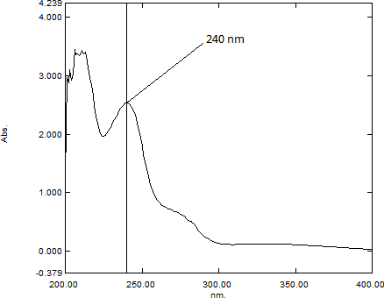

Figure 13 UV - spectra of Diltiazem malate
Recorded UV absorption spectra of Diltiazem malate in the range of 200 to 400nm. (100µg/ml)
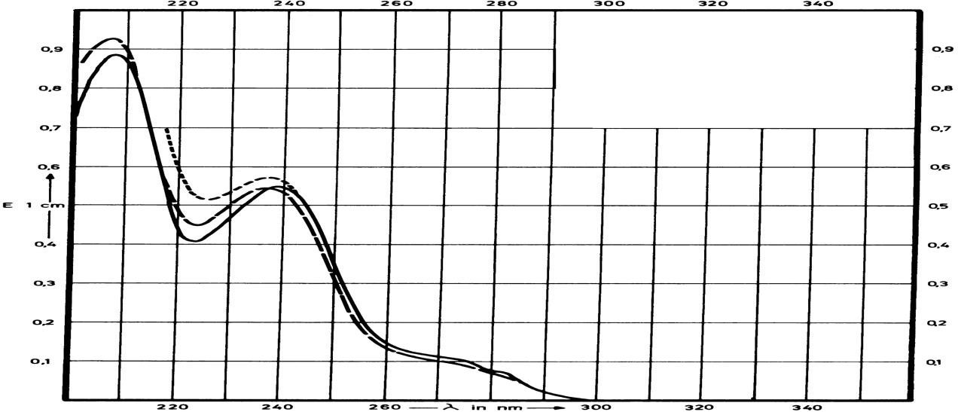

Figure 14 Standard UV absorption spectra of Diltiazem malate (100µg/ml) in the range of 200 to 400 nm.^{[1]}

- For Enalapril maleate:
- Transfer an accurately weighed quantity about 1mg of Enalapril maleate to 10ml volumetric flask and make up to the mark with water. (100µg/mL)

3.100

2.000
Abs.

1.000

-0.091
212.00 250.00 300.00 337.14
nm.

Figure 15 Recorded UV absorption spectra of Enalapril malate. (100µg/ml)

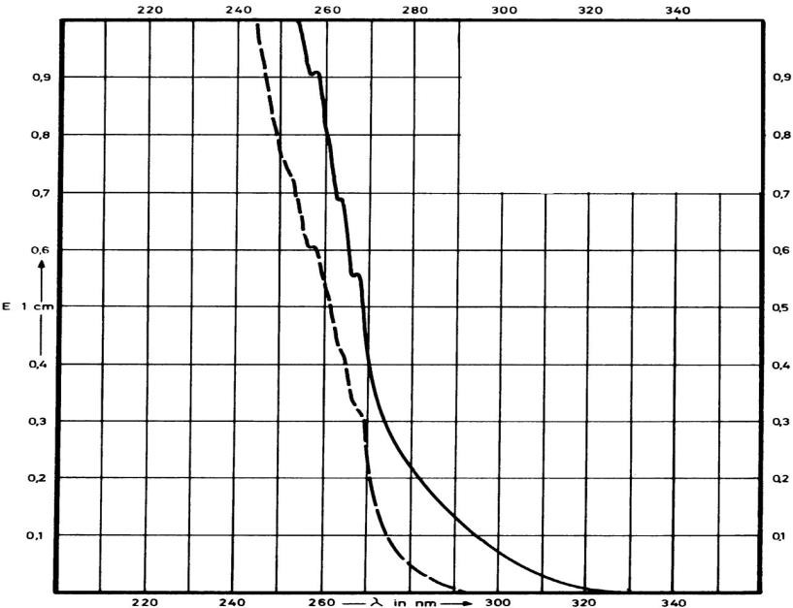
.
Figure 16 standard UV - spectra of Enalapril malate^{[1]}

Identification by IR spectra:
- For Diltiazem malate:
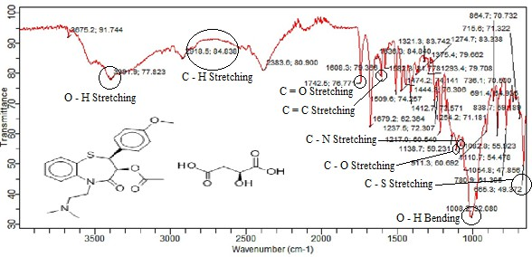

Figure 17 FT-IR spectra of Diltiazem malate

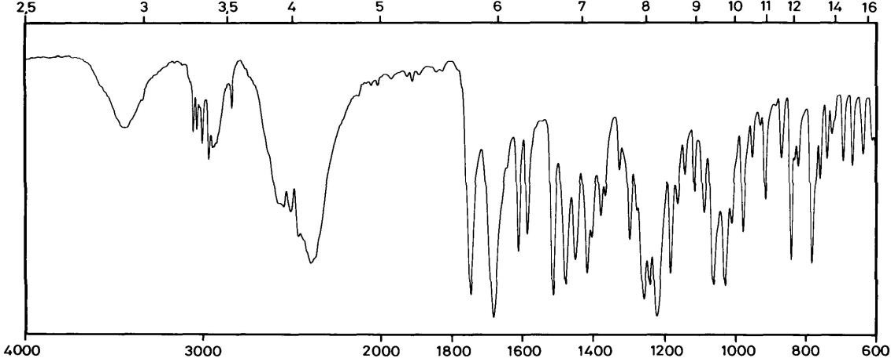

Figure 18 Standard IR spectra of Diltiazem malate^{[1]}

Table 6-2 Interpretation of IR spectra of Diltiazem malate

Sr.  no. | Functional Group | Standard wave number (cm-1)[54] | Observed wave number (cm-1)
1 | C – H Stretching | 3000 – 2850 | 2918.5 (84%)
2 | C – N Stretching | 1020 – 1250 | 1082.8 (55%)
3 | C = O Stretching (Aliphatic) | 1680 – 1750 | 1742.5 (76%)
4 | C – O Stretching | 1100 – 1300 | 1110.7 (54%)
5 | C – S Stretching | 700 – 600 | 665.3 (49%)
6 | C = C Stretching | 1600 – 1650 | 1608.3 (78%)
7 | O – H Stretching | 3500 – 3300 | 3391.9 (77%)
8 | O – H Bending | 937 | 1008.2 (32%)

- For Enalapril maleate:
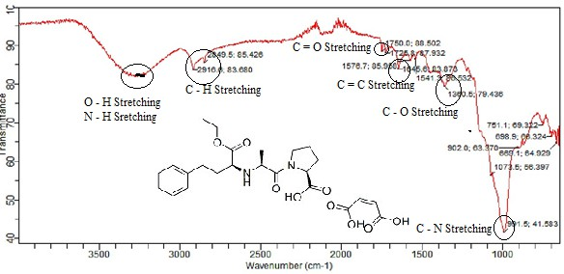

Figure 19 FT - IR Spectra of Enalapril malate (sample)

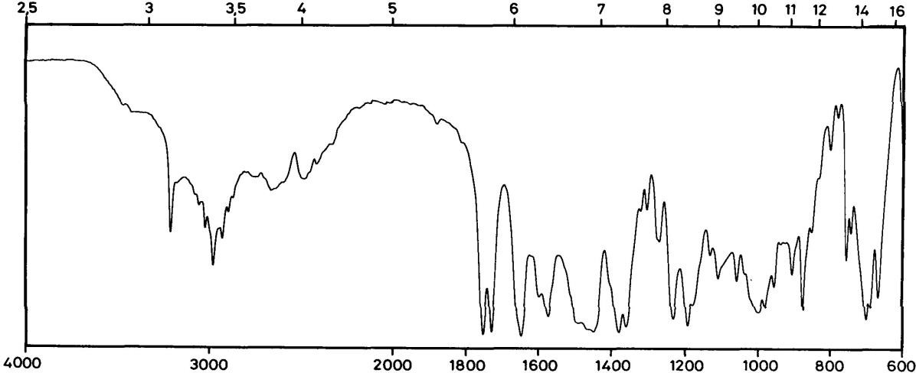
Enalapril malate
Figure 20 Standard IR spectra of enalapril malate^{[1]}

Table 6-3 Interpretation of IR spectra of Enalapril malate:

Sr.  no. | Functional Group | Standard wave number  (cm-1)[54] | Observed wave number (cm-1)
1 | C – H Stretching | 2850 – 3000 | 2849.5 (85%),  2916.6 (83%)
2 | C – O Stretching | 1300 – 1100 | 1360.5 (79%)
3 | C = O Stretching | 1680 – 1750 | 1750.0 (88%)
4 | O – H Stretching | 3300 – 3500 | 3300
5 | C – N Stretching | 1020 – 1250 | 991.5 (41%)
6 | N – H Stretching | 3400 – 3500 | 3300
7 | C = C Stretching | 1600 – 1650 | 1645.6 (83%)

Materials and Methods:

Preparation of dilution scheme for Diltiazem malate:
Table 7-1 Dilution scheme of Diltiazem malate

Sample Preparation
Stock solution: 50mg Drug Dissolved in 50ml of Distilled Water (1000µg/mL)
Master stock solution: 5 ml of stock solution is diluted to 50ml with distilled water (100µg/mL)
Concentration of master stock solution (µg/mL) | Volume of master stock solution taken (mL) | Volume of diluents taken (mL) | Concentration of final mixture (µg/mL)
100 | 3.6 | 6.4 | 36
100 | 4.6 | 5.4 | 46
100 | 5.6 | 4.4 | 56
100 | 6.6 | 3.4 | 66
100 | 7.6 | 2.4 | 76
All above solution were scanned between 200 – 400nm.

Preparation of dilution scheme for Enalapril maleate:
Table 7-2 Dilution scheme of Enalapril malate

Sample preparation
Stock solution: 100 mg Drug Dissolved in 100mL of Distilled Water (1000µg/mL)
Master stock solution: 2.5ml of stock solution is diluted to 25ml with distilled water (100µg/mL)
Concentration of master stock solution (µg/mL) | Volume of master stock solution taken(mL) | Volume of diluents taken (mL) | Concentration of final mixture (µg/mL)
100 | 0.1 | 9.9 | 1
100 | 0.2 | 9.8 | 2
100 | 0.3 | 9.7 | 3
100 | 0.4 | 9.6 | 4
100 | 0.5 | 9.5 | 5
All above solution were scanned between 200 – 400nm.

Design of mixture for Partial Least Square Method (PLS):
The multivariate calibration requires a suitable experimental design of the standard composition of calibration set to provide the best prediction. The factorial design method was used to construct the calibration set. Application of two factorial design led to construction and optimization of PLS model. Thus, two binary set of the drug present in

random ratio were prepared, one set with 5 samples so that total 25 samples were employed for optimization by PLS method: (Table)

Composition of calibration sample:
Table 7-3 composition of calibration sample of DIL and ENA.

Sample | Concentration(µg/mL) |  | Sample | Concentration (µg/mL)
Sr. no. | DIL | ENA | Sr. no. | DIL | ENA
1 | 36 | 1 | 14 | 66 | 3
2 | 46 | 1 | 15 | 76 | 3
3 | 56 | 1 | 16 | 36 | 4
4 | 66 | 1 | 17 | 46 | 4
5 | 76 | 1 | 18 | 56 | 4
6 | 36 | 2 | 19 | 66 | 4
7 | 46 | 2 | 20 | 76 | 4
8 | 56 | 2 | 21 | 36 | 5
9 | 66 | 2 | 22 | 46 | 5
10 | 76 | 2 | 23 | 56 | 5
11 | 36 | 3 | 24 | 66 | 5
12 | 46 | 3 | 25 | 76 | 5
13 | 56 | 3

Preparation of stock solution for diltiazem malate: (For PLS)

Preparation of Master Stock solution
Master stock solution: 50 mg Drug Dissolved in 500ml of Distilled Water (100µg/mL)

Preparation of stock solution for Enalapril malate: (For PLS)

Preparation of master stock solution
Master stock solution: 1mg Drug Dissolved in 10mL of Distilled Water (100µg/mL)

Concentration of master stock solution (µg/mL) (DIL + ENA) | Volume of master stock solution taken (mL) (ENA) | Volume of master stock solution taken (mL)  (DIL) | Volume of diluents taken (mL) | Concentration of mixture (µg/mL) (ENA + DIL)
Diltiazem malate (100µg/mL)  Enalapril maleate (100µg/mL) | 0.1 | 3.6 | 6.3 | 1:36
Diltiazem malate (100µg/mL)  Enalapril maleate (100µg/mL) | 0.1 | 4.6 | 5.3 | 1:46
Diltiazem malate (100µg/mL)  Enalapril maleate (100µg/mL) | 0.1 | 5.6 | 4.3 | 1:56
Diltiazem malate (100µg/mL)  Enalapril maleate (100µg/mL) | 0.1 | 6.6 | 3.3 | 1:66
Diltiazem malate (100µg/mL)  Enalapril maleate (100µg/mL) | 0.1 | 7.6 | 2.3 | 1:76

Table 7-5 Preparation of Set 2

Concentration of master stock solution (µg/mL) (DIL + ENA) | Volume of master stock solution taken (mL) (ENA) | Volume of master stock solution taken (mL)  (DIL) | Volume of diluents taken (mL) | Concentration of mixture (µg/mL) (ENA + DIL)
Diltiazem malate (100µg/mL)  Enalapril maleate (100µg/mL) | 0.2 | 3.6 | 6.2 | 2:36
Diltiazem malate (100µg/mL)  Enalapril maleate (100µg/mL) | 0.2 | 4.6 | 5.2 | 2:46
Diltiazem malate (100µg/mL)  Enalapril maleate (100µg/mL) | 0.2 | 5.6 | 4.2 | 2:56
Diltiazem malate (100µg/mL)  Enalapril maleate (100µg/mL) | 0.2 | 6.6 | 3.2 | 2:66
Diltiazem malate (100µg/mL)  Enalapril maleate (100µg/mL) | 0.2 | 7.6 | 2.2 | 2:76

Table 7-6 Preparation of Set 3

Concentration of master stock solution (µg/mL) (DIL + ENA) | Volume of master stock solution taken (mL) (ENA) | Volume of master stock solution taken (mL)  (DIL) | Volume of diluents taken (mL) | Concentration of mixture (µg/mL) (ENA + DIL)
Diltiazem malate (100µg/mL)  Enalapril maleate (100µg/mL) | 0.3 | 3.6 | 6.1 | 3:36
Diltiazem malate (100µg/mL)  Enalapril maleate (100µg/mL) | 0.3 | 4.6 | 5.1 | 3:46
Diltiazem malate (100µg/mL)  Enalapril maleate (100µg/mL) | 0.3 | 5.6 | 4.1 | 3:56
Diltiazem malate (100µg/mL)  Enalapril maleate (100µg/mL) | 0.3 | 6.6 | 3.1 | 3:66
Diltiazem malate (100µg/mL)  Enalapril maleate (100µg/mL) | 0.3 | 7.6 | 2.1 | 3:76

Table 7-7 Preparation of Set 4

Concentration of master stock solution (µg/mL) (DIL + ENA) | Volume of master stock solution taken (mL) (ENA) | Volume of master stock solution taken (mL)  (DIL) | Volume of diluents taken (mL) | Concentration of mixture (µg/mL) (ENA + DIL)
Diltiazem malate (100µg/mL)  Enalapril maleate (100µg/mL) | 0.4 | 3.6 | 6.0 | 4:36
Diltiazem malate (100µg/mL)  Enalapril maleate (100µg/mL) | 0.4 | 4.6 | 5.0 | 4:46
Diltiazem malate (100µg/mL)  Enalapril maleate (100µg/mL) | 0.4 | 5.6 | 4.0 | 4:56
Diltiazem malate (100µg/mL)  Enalapril maleate (100µg/mL) | 0.4 | 6.6 | 3.0 | 4:66
Diltiazem malate (100µg/mL)  Enalapril maleate (100µg/mL) | 0.4 | 7.6 | 2.0 | 4:76

Table 7-8 Preparation of Set 5

Concentration of master stock solution (µg/mL) (DIL + ENA) | Volume of master stock solution taken (mL) (ENA) | Volume of master stock solution taken (mL)  (DIL) | Volume of diluents taken (mL) | Concentration of mixture (µg/mL) (ENA + DIL)
Diltiazem malate (100µg/mL)  Enalapril maleate (100µg/mL) | 0.5 | 3.6 | 5.9 | 5:36
Diltiazem malate (100µg/mL)  Enalapril maleate (100µg/mL) | 0.5 | 4.6 | 4.9 | 5:46
Diltiazem malate (100µg/mL)  Enalapril maleate (100µg/mL) | 0.5 | 5.6 | 3.9 | 5:56
Diltiazem malate (100µg/mL)  Enalapril maleate (100µg/mL) | 0.5 | 6.6 | 2.9 | 5:66
Diltiazem malate (100µg/mL)  Enalapril maleate (100µg/mL) | 0.5 | 7.6 | 1.9 | 5:76

Optimization by PLS method:

From above scheme, all the sets of solutions were prepared and the spectra were recorded in UV 1800 between the range of 200-400nm.
↓
All the recorded UV spectra were observed in UV probe (Ver. 2.42) and the range of wavelength is selected between 220-290nm by observing each spectrum.
↓
The interval of wavelength is kept 3nm, and all the calibration data are gathered by data print option.
↓
Now, the calibration data obtained from experimental were gathered in a matrix data by Microsoft Office Excel (Ver. 1811) (all the data were transpose in Microsoft office Excel).
↓
Then these all data are subjected to PCR treatment by XLSTAT (ver.2019)
↓
And these all data are subjected to PLS treatment by XLSTAT (ver.2019)

  - Preparation of validation set for diltiazem malate an enalapril malate:
Table 7-9 Preparation of validation set for DIL and ENA

Concentration of Master stock solution  (µg/ml) | Volume of master stock (ml)  ENA | Volume of master stock solution (ml) DIL | Volume of diluents taken (ml) | Concentration of Mixture (µg/ml)
100 | 0.1 | 4.6 | 5.3 | 1 + 46
100 | 0.2 | 4.6 | 5.2 | 2 + 46
100 | 0.2 | 5.6 | 4.2 | 2 + 56
100 | 0.3 | 5.6 | 4.1 | 3 +56
100 | 0.3 | 6.6 | 3.1 | 3 + 66
100 | 0.4 | 4.6 | 5 | 4 + 46
100 | 0.4 | 5.6 | 4 | 4 + 56
100 | 0.4 | 6.6 | 3 | 4 + 66
100 | 0.5 | 6.6 | 2.9 | 5 + 66

Accuracy study of Diltiazem malate and Enalapril malate:
Table 7-10 Accuracy study of DIL and ENA

Preparation of master stock solution
Standard solution: 2.5mg DIL and 2.5mg ENA dissolved in 25ml distilled water, individually 100µg/ml of DIL and ENA.
Level of spiking | Blank (mL) | Volume of standard solution (mL) |  | Volume of diluents taken (mL) |  | Final concentration (µg/ml)
Level of spiking | Blank (mL) | DIL | ENA | DIL | ENA | DIL | ENA
Unspiked | 0 | - | - | 10 |  | - | -
80% | 0 | 3.68 | 0.16 | 6.16 |  | 36.8 | 1.6
100% | 0 | 4.6 | 0.2 | 5.2 |  | 46 | 2
120% | 0 | 5.52 | 0.24 | 4.24 |  | 55.2 | 2.4

Assay preparation of DIL and ENA by PLS method:
Table 7-11 Assay preparation table for DIL and ENA

Content Ratio of mixture: 5mg of ENA and 180mg of DIL
Sample preparation
Master stock solution: | 25mg ENA and 25mg DIL dissolved in 25ml Distilled water, 1000µg/ml of ENA and DIL.
Stock solution: | Withdraw 2.5ml from master stock solution from each 25ml volumetric flask which contain 100µg/ml.
All above solution were scanned between 200 – 400 nm.

Table 7-12 Test Solution of DIL and ENA

Test solution of ENA: withdraw 0.2ml from stock solution, in 10ml of volumetric flask and make up the volume with Distilled water. (2µg/ml)
Test solution of DIL: withdraw 4.6ml from stock solution, in 10ml of volumetric flask and make up the volume with Distilled water. (46µg/ml)

Result and Discussion:

  - UV – spectra of Diltiazem malate and Enalapril malate for PLS Method: From each set of solution, different spectra were recorded in shimadzu UV 1800 double beam spectrophotometer between the wavelength range of 200nm to 400nm
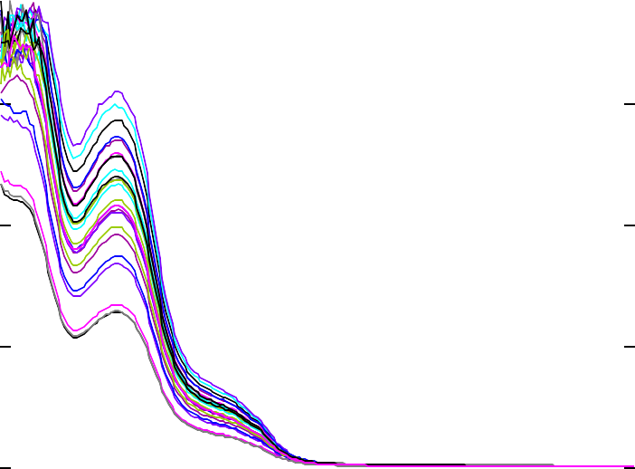
4.239
4.000

3.000

2.000
Abs.

1.000

0.000

-0.379
200.00 250.00 300.00 350.00 400.00
nm.

Figure 21 UV - Spectra of DIL and ENA by PLS method

Training set of Diltiazem malate and Enalapril malate:
Table 8-1 Training set of DIL and ENA

Concentration |  | Wavelength | 220 | 223 | 226 | 229 | 232 | 235 | 238 | 241 | 244 | 247
Enalapril | Diltiazem
1 | 36 |  | 1.165 | 1.077 | 1.102 | 1.169 | 1.233 | 1.277 | 1.28 | 1.225 | 1.101 | 0.911
1 | 46 |  | 1.577 | 1.458 | 1.492 | 1.584 | 1.672 | 1.732 | 1.738 | 1.663 | 1.494 | 1.235
1 | 56 |  | 1.949 | 1.804 | 1.851 | 1.969 | 2.076 | 2.149 | 2.15 | 2.057 | 1.846 | 1.522
1 | 66 |  | 2.231 | 2.059 | 2.114 | 2.244 | 2.365 | 2.444 | 2.446 | 2.34 | 2.105 | 1.74
1 | 76 |  | 2.472 | 2.279 | 2.334 | 2.476 | 2.614 | 2.682 | 2.696 | 2.573 | 2.325 | 1.929
2 | 36 |  | 1.175 | 1.085 | 1.11 | 1.177 | 1.241 | 1.282 | 1.284 | 1.226 | 1.101 | 0.908
2 | 46 |  | 1.527 | 1.407 | 1.438 | 1.525 | 1.611 | 1.669 | 1.675 | 1.605 | 1.445 | 1.195
2 | 56 |  | 2.002 | 1.847 | 1.887 | 2.004 | 2.117 | 2.192 | 2.208 | 2.111 | 1.903 | 1.577
2 | 66 |  | 2.342 | 2.167 | 2.219 | 2.353 | 2.486 | 2.568 | 2.569 | 2.446 | 2.209 | 1.827
2 | 76 |  | 2.493 | 2.312 | 2.366 | 2.501 | 2.631 | 2.708 | 2.72 | 2.594 | 2.345 | 1.942
3 | 36 |  | 1.23 | 1.134 | 1.159 | 1.229 | 1.297 | 1.341 | 1.341 | 1.281 | 1.15 | 0.948
3 | 46 |  | 2.125 | 1.965 | 2.014 | 2.131 | 2.249 | 2.321 | 2.324 | 2.222 | 2.003 | 1.654
3 | 56 |  | 1.93 | 1.777 | 1.819 | 1.932 | 2.041 | 2.112 | 2.117 | 2.025 | 1.825 | 1.508
3 | 66 |  | 2.338 | 2.157 | 2.218 | 2.354 | 2.492 | 2.557 | 2.563 | 2.442 | 2.198 | 1.813
3 | 76 |  | 2.883 | 2.661 | 2.727 | 2.874 | 2.999 | 3.063 | 3.091 | 2.94 | 2.699 | 2.248
4 | 36 |  | 1.812 | 1.671 | 1.71 | 1.814 | 1.913 | 1.975 | 1.977 | 1.89 | 1.699 | 1.402
4 | 46 |  | 2.197 | 2.031 | 2.071 | 2.2 | 2.323 | 2.39 | 2.392 | 2.289 | 2.064 | 1.707
4 | 56 |  | 1.956 | 1.808 | 1.852 | 1.967 | 2.077 | 2.144 | 2.149 | 2.054 | 1.843 | 1.52
4 | 66 |  | 2.353 | 2.181 | 2.231 | 2.369 | 2.493 | 2.575 | 2.577 | 2.46 | 2.219 | 1.838
4 | 76 |  | 2.761 | 2.547 | 2.621 | 2.775 | 2.912 | 2.968 | 2.965 | 2.847 | 2.593 | 2.165
5 | 36 |  | 1.746 | 1.611 | 1.65 | 1.75 | 1.844 | 1.906 | 1.909 | 1.822 | 1.634 | 1.349
5 | 46 |  | 2.178 | 2.01 | 2.057 | 2.177 | 2.294 | 2.364 | 2.368 | 2.264 | 2.04 | 1.687
5 | 56 |  | 1.925 | 1.783 | 1.822 | 1.933 | 2.034 | 2.098 | 2.099 | 2.007 | 1.801 | 1.489
5 | 66 |  | 2.175 | 2.009 | 2.057 | 2.177 | 2.291 | 2.362 | 2.367 | 2.262 | 2.033 | 1.681
5 | 76 |  | 2.644 | 2.448 | 2.5 | 2.656 | 2.772 | 2.851 | 2.859 | 2.736 | 2.481 | 2.068

250 | 253 | 256 | 259 | 262 | 265 | 268 | 271 | 274 | 277 | 280 | 283 | 286 | 289
0.696 | 0.523 | 0.412 | 0.347 | 0.31 | 0.287 | 0.27 | 0.254 | 0.235 | 0.207 | 0.181 | 0.149 | 0.106 | 0.072
0.944 | 0.71 | 0.559 | 0.471 | 0.422 | 0.391 | 0.367 | 0.346 | 0.32 | 0.281 | 0.246 | 0.204 | 0.144 | 0.098
1.159 | 0.87 | 0.684 | 0.575 | 0.514 | 0.476 | 0.446 | 0.42 | 0.387 | 0.339 | 0.294 | 0.241 | 0.167 | 0.109
1.326 | 0.998 | 0.787 | 0.664 | 0.594 | 0.551 | 0.517 | 0.487 | 0.45 | 0.395 | 0.343 | 0.283 | 0.198 | 0.132
1.474 | 1.112 | 0.876 | 0.739 | 0.661 | 0.612 | 0.574 | 0.541 | 0.5 | 0.438 | 0.381 | 0.315 | 0.219 | 0.146
0.692 | 0.521 | 0.411 | 0.346 | 0.31 | 0.287 | 0.27 | 0.254 | 0.235 | 0.206 | 0.18 | 0.149 | 0.105 | 0.071
0.912 | 0.686 | 0.539 | 0.454 | 0.406 | 0.376 | 0.353 | 0.333 | 0.308 | 0.27 | 0.236 | 0.196 | 0.137 | 0.093
1.201 | 0.9 | 0.704 | 0.59 | 0.526 | 0.486 | 0.455 | 0.428 | 0.395 | 0.346 | 0.3 | 0.246 | 0.169 | 0.111
1.391 | 1.045 | 0.82 | 0.689 | 0.615 | 0.569 | 0.533 | 0.501 | 0.462 | 0.403 | 0.349 | 0.286 | 0.195 | 0.126
1.483 | 1.118 | 0.882 | 0.744 | 0.667 | 0.619 | 0.58 | 0.547 | 0.506 | 0.443 | 0.385 | 0.318 | 0.221 | 0.147
0.724 | 0.545 | 0.43 | 0.363 | 0.325 | 0.301 | 0.283 | 0.267 | 0.247 | 0.217 | 0.189 | 0.157 | 0.11 | 0.075
1.26 | 0.948 | 0.746 | 0.628 | 0.562 | 0.52 | 0.487 | 0.458 | 0.424 | 0.371 | 0.322 | 0.265 | 0.184 | 0.121
1.15 | 0.863 | 0.676 | 0.567 | 0.506 | 0.468 | 0.438 | 0.412 | 0.38 | 0.332 | 0.288 | 0.237 | 0.163 | 0.106
1.378 | 1.036 | 0.815 | 0.686 | 0.613 | 0.567 | 0.531 | 0.498 | 0.459 | 0.4 | 0.346 | 0.282 | 0.192 | 0.123
1.725 | 1.297 | 1.021 | 0.858 | 0.767 | 0.709 | 0.664 | 0.625 | 0.576 | 0.503 | 0.435 | 0.357 | 0.244 | 0.158
1.071 | 0.806 | 0.636 | 0.536 | 0.479 | 0.444 | 0.416 | 0.392 | 0.362 | 0.317 | 0.276 | 0.228 | 0.16 | 0.107
1.305 | 0.981 | 0.774 | 0.652 | 0.583 | 0.539 | 0.506 | 0.477 | 0.44 | 0.386 | 0.336 | 0.278 | 0.195 | 0.13
1.158 | 0.869 | 0.683 | 0.575 | 0.513 | 0.475 | 0.445 | 0.418 | 0.386 | 0.337 | 0.293 | 0.24 | 0.166 | 0.109
1.402 | 1.053 | 0.828 | 0.697 | 0.622 | 0.575 | 0.539 | 0.507 | 0.467 | 0.408 | 0.354 | 0.291 | 0.201 | 0.131
1.656 | 1.245 | 0.98 | 0.826 | 0.737 | 0.682 | 0.639 | 0.601 | 0.554 | 0.485 | 0.42 | 0.344 | 0.237 | 0.154
1.028 | 0.773 | 0.608 | 0.513 | 0.458 | 0.424 | 0.398 | 0.374 | 0.345 | 0.302 | 0.263 | 0.216 | 0.151 | 0.1
1.287 | 0.97 | 0.766 | 0.647 | 0.579 | 0.536 | 0.503 | 0.474 | 0.438 | 0.384 | 0.335 | 0.277 | 0.194 | 0.131
1.138 | 0.86 | 0.681 | 0.575 | 0.515 | 0.477 | 0.447 | 0.421 | 0.389 | 0.342 | 0.299 | 0.248 | 0.175 | 0.12
1.285 | 0.969 | 0.765 | 0.646 | 0.579 | 0.536 | 0.503 | 0.474 | 0.438 | 0.384 | 0.335 | 0.277 | 0.195 | 0.131
1.58 | 1.188 | 0.934 | 0.784 | 0.7 | 0.647 | 0.607 | 0.57 | 0.526 | 0.459 | 0.398 | 0.327 | 0.224 | 0.146

Eigenvalues of Diltiazem malate and Enalapril malate by Principal Component Analysis (PCA):
Table 8-2 Eigenvalue of DIL and ENA by PCA
Principal Component Analysis:
Eigenvalues:
 | F1 | F2 | F3 | F4 | F5 | F6 | F7 | F8 | F9 | F10
Eigenvalue | 23.928 | 0.065 | 0.005 | 0.001 | 0.000 | 0.000 | 0.000 | 0.000 | 0.000 | 0.000
Variability (%) | 99.701 | 0.270 | 0.020 | 0.004 | 0.002 | 0.001 | 0.001 | 0.000 | 0.000 | 0.000
Cumulative  % | 99.701 | 99.971 | 99.991 | 99.996 | 99.998 | 99.998 | 99.999 | 99.999 | 99.999 | 100.000

F11 | F12 | F13 | F14 | F15 | F16 | F17 | F18 | F19 | F20 | F21 | F22 | F23
0.000 | 0.000 | 0.000 | 0.000 | 0.000 | 0.000 | 0.000 | 0.000 | 0.000 | 0.000 | 0.000 | 0.000 | 0.000
0.000 | 0.000 | 0.000 | 0.000 | 0.000 | 0.000 | 0.000 | 0.000 | 0.000 | 0.000 | 0.000 | 0.000 | 0.000
100.000 | 100.000 | 100.000 | 100.000 | 100.000 | 100.000 | 100.000 | 100.000 | 100.000 | 100.000 | 100.000 | 100.000 | 100.000

Statistical analysis of Enalapril malate by PLS method:
Table 8-3 Statistical analysis of ENA by PLS Method

Observation | Weight | Actual value | Predicted data (1) | Residual | Standard residual | Standard Deviation (SD) | Mean | Relative standard Deviation  (RSD)
1 | 1 | 1.000 | 0.993 | 0.007 | 1.384 | 0.009 | 1.006 | 0.916
2 | 1 | 1.000 | 1.013 | -0.013 | -2.035 | 0.009 | 1.006 | 0.916
3 | 1 | 1.000 | 1.012 | -0.012 | -1.926 | 0.009 | 1.006 | 0.916
4 | 1 | 1.000 | 1.005 | -0.005 | -1.167 | 0.009 | 1.006 | 0.916
5 | 1 | 2.000 | 2.054 | -0.054 | -0.723 | 0.047 | 1.980 | 2.376
6 | 1 | 2.000 | 1.991 | 0.009 | -0.234 | 0.047 | 1.980 | 2.376
7 | 1 | 2.000 | 1.928 | 0.072 | 1.106 | 0.047 | 1.980 | 2.376
8 | 1 | 2.000 | 1.965 | 0.035 | 0.319 | 0.047 | 1.980 | 2.376
9 | 1 | 2.000 | 1.962 | 0.038 | 0.383 | 0.047 | 1.980 | 2.376
10 | 1 | 3.000 | 3.003 | -0.003 | -0.952 | 0.037 | 3.032 | 1.219
11 | 1 | 3.000 | 3.027 | -0.027 | -1.601 | 0.037 | 3.032 | 1.219
12 | 1 | 3.000 | 3.029 | -0.029 | -1.655 | 0.037 | 3.032 | 1.219
13 | 1 | 3.000 | 3.007 | -0.007 | -1.060 | 0.037 | 3.032 | 1.219
14 | 1 | 3.000 | 3.095 | -0.095 | -1.698 | 0.037 | 3.032 | 1.219
15 | 1 | 4.000 | 3.998 | 0.002 | 0.206 | 0.054 | 4.009 | 1.358
16 | 1 | 4.000 | 4.104 | -0.104 | -1.741 | 0.054 | 4.009 | 1.358
17 | 1 | 4.000 | 3.996 | 0.004 | 0.242 | 0.054 | 4.009 | 1.358
18 | 1 | 4.000 | 3.981 | 0.019 | 0.518 | 0.054 | 4.009 | 1.358
19 | 1 | 4.000 | 3.967 | 0.033 | 0.775 | 0.054 | 4.009 | 1.358
20 | 1 | 5.000 | 5.101 | -0.101 | -1.507 | 0.078 | 4.984 | 1.558
21 | 1 | 5.000 | 5.013 | -0.013 | -0.373 | 0.078 | 4.984 | 1.558
22 | 1 | 5.000 | 4.914 | 0.086 | 0.901 | 0.078 | 4.984 | 1.558
23 | 1 | 5.000 | 4.976 | 0.024 | 0.103 | 0.078 | 4.984 | 1.558
24 | 1 | 5.000 | 4.916 | 0.084 | 0.876 | 0.078 | 4.984 | 1.558

Result and Discussion

Figure 22 standard residual matrix
Pred(1)/Standardized Residuals
0.100
0.050
0.000
0
2
4
6
-0.050
-0.100
-0.150
1
Correlation matrix (pred(1) vs Actual values)
6
5
4
3
2
1
0
0.000 1.000 2.000
3.000
Actual Value
4.000 5.000 6.000
Standardized residuals
Predicted value
Standardized residuals
Figure 23 Predicted standard residual matrix

1 / Standardized residuals
2

1.5

1

0.5

0
0
2
4
6
-0.5

-1

-1.5

-2
1

Figure 24 correlation matrix between Actual and Predicted concentration

Result and Discussion

Statistical analysis of Diltiazem malate by PLS method:
Table 8-4 Statistical analysis of DIL by PLS method

Observation | Weight | Actual value | Predicted value | Residual | Standard residual | Standard Deviation | Mean | RSD | Mean of Residual | Std. dev.
1 | 1 | 36.000 | 36.124 | -0.124 | -0.960 | 0.134 | 35.995 | 0.373 | 0.005 | 0.13433
2 | 1 | 36.000 | 36.091 | -0.091 | -0.715
3 | 1 | 36.000 | 35.921 | 0.079 | 0.551
4 | 1 | 36.000 | 35.844 | 0.156 | 1.124
5 | 1 | 46.000 | 46.204 | -0.204 | -1.227 | 0.191 | 45.970 | 0.415 | 0.030 | 0.190752
6 | 1 | 46.000 | 46.122 | -0.122 | -0.797
7 | 1 | 46.000 | 45.831 | 0.169 | 0.729
8 | 1 | 46.000 | 45.752 | 0.248 | 1.143
9 | 1 | 46.000 | 45.941 | 0.059 | 0.152
10 | 1 | 56.000 | 56.433 | -0.433 | -0.942 | 0.302 | 56.148 | 0.538 | -0.148 | 0.302104
11 | 1 | 56.000 | 56.347 | -0.347 | -0.657
12 | 1 | 56.000 | 56.311 | -0.311 | -0.538
13 | 1 | 56.000 | 55.756 | 0.244 | 1.299
14 | 1 | 56.000 | 55.895 | 0.105 | 0.839
15 | 1 | 66.000 | 66.138 | -0.138 | 0.405 | 0.259 | 66.243 | 0.390 | -0.243 | 0.258537
16 | 1 | 66.000 | 66.544 | -0.544 | -1.166
17 | 1 | 66.000 | 66.421 | -0.421 | -0.690
18 | 1 | 66.000 | 66.233 | -0.233 | 0.037
19 | 1 | 66.000 | 65.877 | 0.123 | 1.414
20 | 1 | 76.000 | 75.621 | 0.379 | 1.091 | 0.348 | 76.001 | 0.458 | -0.001 | 0.348228
21 | 1 | 76.000 | 76.345 | -0.345 | -0.988
22 | 1 | 76.000 | 75.714 | 0.286 | 0.824
23 | 1 | 76.000 | 75.953 | 0.047 | 0.138
24 | 1 | 76.000 | 76.372 | -0.372 | -1.065

0 40 | 50 | 60 | 70 | 80

Figure 25 Standardized residual matrix of DIL
Pred(36) / Standardized residuals
0.600
0.400
0.200
0.000
3
-0.200
-0.400
-0.600
Pred(36)
36 / Standardized residuals
1
0.5
0
30
40
50 60
70
80
-0.5
-1
-1.5
36
Standardized residuals
Standardized residuals
Figure 26 Predicted standard residual matrix of ENA

Figure 27 Correlation matrix between Actual and Predicted concentration
Corelation matrix between actual and Predicted Values
80
75
70
65
60
55
50
45
40
35
30
30.000
40.000
50.000
60.000
70.000
80.000

Accuracy data of DIL and ENA at 80, 100 and 120% of target concentration.
Table 8-5 Accuracy data of DIL and ENA

Level of Spiking | Blank (ml) | Amount of std. drug added (µg/ml) |  | Amount of drug recovery (µg/ml) |  | %Recovery
Level of Spiking | Blank (ml) | DIL | ENA | DIL | ENA | DIL | ENA
Unspiked | - | - | - | - | - | - | -
80% | 0 | 36.8 | 1.6 | 36.66±0.56 | 1.58±0.02 | 99.63±1.54 | 98.93±1.68
100% | 0 | 46 | 2 | 45.76±0.39 | 1.98 ± 0.02 | 99.47±0.87 | 99.48±1.20
120% | 0 | 55.2 | 2.4 | 55.12±0.20 | 2.39±0.02 | 99.85±0.37 | 99.65±1.00

    - ICH Criteria: %Recovery should be within 98% - 102%.
    - Development method is accurate over the range of 1 – 5 µg/ml and 36 – 76 µg/ml for ENA and DIL respectively.

Assay data of DIL and ENA:
Table 8-6 assay data of DIL and ENA

Drug | Amount taken (µg/ml) | Amount recovery (µg/ml) | %Assay
DIL | 46 | 45.89±0.17 | 99.77±0.37
ENA | 2 | 1.99±0.01 | 99.88±0.51

Validation set analysis by PLS method for Diltiazem malate:
Table 8-7 Validation set analysis by PLS method foe DIL

Observation | Weight | Actual value | Predicted value | Residual | Std. Residual | Mean | SD
Obs1 | 1 | 46.000 | 46.122 | -0.122 | -0.70710678 | -0.107 | 0.02192
Obs2 | 1 | 46.000 | 46.091 | -0.091 | 0.70710678 | -0.107 | 0.02192
Obs3 | 1 | 56.000 | 55.842 | 0.158 | 0.58214149 | 0.037 | 0.208426
Obs4 | 1 | 56.000 | 55.844 | 0.156 | 0.57254575 | 0.037 | 0.208426
Obs5 | 1 | 56.000 | 56.204 | -0.204 | -1.15468725 | 0.037 | 0.208426
Obs6 | 1 | 66.000 | 66.122 | -0.122 | -1.13072762 | 0.098 | 0.19486
Obs7 | 1 | 66.000 | 65.831 | 0.169 | 0.36265394 | 0.098 | 0.19486
Obs8 | 1 | 66.000 | 65.752 | 0.248 | 0.76807368 | 0.098 | 0.19486

Standardized validation matrix of Diltiazem malate Predicted validation matrix of Diltiazem malate
46 / Standardized residuals
1
0.5
0
45
50
55
60
65
70
-0.5
-1
-1.5
-2
-2.5
46
46 / Standardized residuals
1
0.5
0
45
50
55
60
65
70
-0.5
-1
-1.5
-2
-2.5
46
Standardized residuals
Standardized residuals
Figure 28 Standardized and Predicted validation matrix of DIL

Validation set analysis by PLS method for Enalapril malate:
Table 8-8 Validation set analysis by PLS method for ENA
1 / Standardized residuals
2
1.5
1
0.5
0
2
2.5
3
3.5 4
4.5
5
5.5
-0.5
-1
-1.5
1
1 / Standardized residuals
2
1.5
1
0.5
0
2
2.5
3
3.5
4
4.5
5
5.5
-0.5
-1
-1.5
1

Observation | Weight | Actual value | Predicted value | Residual | Std. Residual | Mean | SD
Obs1 | 1 | 2.000 | 1.993 | 0.007 | -0.70710678 | 0.047 | 0.056569
Obs2 | 1 | 2.000 | 1.913 | 0.087 | 0.70710678 | 0.047 | 0.056569
Obs3 | 1 | 3.000 | 2.912 | 0.088 | 0.70710678 | 0.032 | 0.079903
Obs4 | 1 | 3.000 | 3.025 | -0.025 | -0.70710678 | 0.032 | 0.079903
Obs5 | 1 | 4.000 | 3.954 | 0.046 | -0.79391197 | 0.032 | 0.079903
Obs6 | 1 | 4.000 | 3.921 | 0.079 | 1.12309498 | 0.060 | 0.017214
Obs7 | 1 | 4.000 | 3.946 | 0.054 | -0.32918301 | 0.060 | 0.017214
Obs8 | 1 | 5.000 | 4.957 | 0.043 | 0 | 0.060 | 0.017214

Standardized validation matrix of Enalapril malate predicted validation matrix of Enalapril malate
Standardized residuals
Standardized residuals

Figure 29 Standardized and Predicted validation matrix of ENA

Plan of work:
Selection of drug
Diltiazem malate and Enalapril Malate
Review of Literature
Research and Review article
DP-Phase I
DP-Phase I thesis submission/PSAR/Minor review/Research project
DP-Phase I Submission, viva, Presentation

Structural characterization
Melting point, IR, UV
Method development
UV-visible spectrophotometry (PLS method)
Mid – semester review, viva, presentation
As per ICH Q2(R1)

Method validation

Thesis preparation

Comment Compliance Report:

Comment Received | Compliance
Change in title | “Development and validation of analytical methods for determination of Diltiazem malate and Enalapril malate from its fixed dose combination”
More literature review should be done. | Literature review has been done in depth but no method has been found on composition
More details should be mentioned regarding Russian patent about enalapril. | Suggested Russian patent about enalapril was studied in detailed.
Reference as per GTU. | Reference were formated according to GTU guidelines

- Reference:
- RobinsonJW., FrameES., and FrameGM. Undergraduate Instrumental Analysis; CRC Press, 2014.
- GhodkeAY., PoulBN., and PatilBR., "Analytical method development and validation for the estimation of diltiazem hydrochloride in bulk and pharmaceutical dosage form by RP-HPLC." International Journal of Pharmaceutical Chemistry and Analysis. 2014, 1(1), 58-64.
- hollerS., gouch., principle of instrumental analysis; sixth ed; ccengage learning, 2016, 332-358.
- WillardM., Dean., and Settle., Instrumental method of analysis; seventh ed; CBS publication and district pvt. ltd, 2012, 118-196, 513-539.
- Donald L., Pavia., G.M.L., Goorge S., Kriz., James R., Vyvyan., Spectroscopy; second ed; brooks/Cole Cengage learning,2009,367-394.
- BrounRD., Introduction to instrumental Analysis; PharmaMed Press,2006, 261-298, 839-889.
- SharmaB. Instrumental methods of chemical analysis; thirteenth ed; Krishna Prakashan Media, 2015, 68-192, 286-385.
- Kamboj PC. Pharmaceutical Analysis; first ed; Vol. third, 2011, 103-164.
- SchirmerRE. Modern method of pharmaceutical analysis; second ed; Vol. 1, CRC Press, 2010, 31-70.
- BarclayD., Higgins C., and Thompson R., "The Partial Least Squares (pls) Approach to Casual Modeling: Personal Computer Adoption Ans Use as an Illustration." 1995.
- BorgaM., Landelius T., and Knutsson H. "A unified approach to pca, pls, mlr and cca." 1997.
- Butler, N.A. and M.C. Denham, "The peculiar shrinkage properties of partial least squares regression." Journal of the Royal Statistical Society: Series B (Statistical Methodology). 2000, 62(3),585-593.
- Carter Hill, R., T.B. Fomby, and S. Johnson, "Component selection norms for principal components regression." Communications in Statistics-Theory and Methods. 1977, 6(4), 309-334.
- ChatfieldC. and Collins A.J, "Principal component analysis, in Introduction to multivariate analysis." 1980, 57-81.
- Chin, W.W, "How to write up and report PLS analyses, in Handbook of partial least squares." 2010, 655-690.
- De Jong, S.," PLS shrinks." Journal of chemometrics. 1995, 9(4),323-326.
- Druilhet, P. and A. Mom, "PLS regression: a directional signal-to-noise ratio approach." Journal of multivariate analysis. 2006. 97(6),1313-1329.
- Elden, L., "Partial least-squares vs. Lanczos bidiagonalization—I: analysis of a projection method for multiple regression. Computational Statistics & Data Analysis". 2004, 46(1), 11-31.
- Frank, I.E., "A nonlinear PLS model." Chemometrics and intelligent laboratory systems.1990, 8(2), 109-119.
- Geladi, P. and B.R. Kowalski, "Partial least-squares regression: a tutorial."
Analytica chimica acta. 1986, 185,1-17.

- Hair Jr, J.F., et al., "A primer on partial least squares structural equation modeling (PLS-SEM)" 2016.
- Helland, I., "Partial least squares regression." Wiley StatsRef: Statistics Reference Online. 2014.
- Hulland, J., "Use of partial least squares (PLS) in strategic management research: A review of four recent studies." Strategic management journal. 1999, 20(2), 195-204.
- Jong, S.d., B.M. Wise, and N.L. Ricker, "Canonical partial least squares and continuum power regression." Journal of Chemometrics: A Journal of the Chemometrics Society. 2001, 15(2), 85-100.
- Lee, H., Y.M. Park, and S. Lee, "Principal Component Regression by Principal Component Selection." Communications for Statistical Applications and Methods. 2015, 22(2), 173-180.
- Massart, D.L. Handbook of chemometrics and qualimetrics; 1997.
- Norgaard, L., et al., "Interval partial least-squares regression (iPLS): a comparative chemometric study with an example from near-infrared spectroscopy." Applied Spectroscopy. 2000, 54(3), 413-419.
- Rosipal, R. and N. Krämer. "Overview and recent advances in partial least squares. in International Statistical and Optimization Perspectives Workshop" Subspace, Latent Structure and Feature Selection". 2005.
- Sharma, A. and D.W. Jacobs, "Bypassing synthesis: PLS for face recognition with pose, low-resolution and sketch." 2011.
- Vinzi, V.E., C.N. Lauro, and S. Amato, "PLS typological regression: algorithmic, classification and validation issues, in New developments in classification and data analysis." 2005, 133-140.
- Yu, H. and J.F. MacGregor, "Post processing methods (PLS–CCA): simple alternatives to preprocessing methods (OSC–PLS)." Chemometrics and intelligent laboratory systems. 2004, 73(2), 199-205.
- Zhu, E. and R.M. Barnes, "A simple iteration algorithm for PLS regression."
Journal of chemometrics. 1995, 9(5), 363-372.
- Kar, A. Pharmaceutical Analysis; first ed; CBS publisher, 2009, 243-269.
- Kamboj, P.C. Pharmaceutical Analysis; first ed; Vol. second; Vallabh publication, 2010, 239-280.
- Ahuja, S. and M. Dong, Handbook of Pharmaceutical Analysis by HPLC; Vol. six; Elsevier Science,2009.
- Sethi, P.D. HPLC (high performance liquid chromatography) Quantitative analysis of pharmaceutical formulation; Vol. 1; CBS Publisher, 2008, 1- 212.
- Ravisankar, P., "A Review on Step-by-Step Analytical Method Validation."
IOSR Journal of Pharmacy, 2015, 5(10), 7-19.
- https://pubchem.ncbi.nlm.nih.gov/compound/Diltiazem_malate.
- https://pubchem.ncbi.nlm.nih.gov/compound/Enalapril_maleate.
- Pharmacopoeia, I., 2010. The Indian Pharmacopoeia Commission, Ghaziabad.
- Sultana, N., et al., "Development of a RP-HPLC method for the simultaneous analysis of diltiazem and statin: Application in

pharmaceuticals and human serum." Analytical Methods. 2010, 2(10), 1571-
1576.
- Pietras, R., D. Kowalczuk, and H. Hopkala, "Comparison of classical and derivative UV-spectrophotometric methods for the quantification of diltiazem and mexiletine." Acta poloniae pharmaceutica. 2004, 61, 315-
320.
- Abu-Shandi, K.H., "HPLC method development for the simultaneous determination and validation of Diltiazem hydrochloride and its major metabolite desacetyl Diltiazem hydrochloride."
- Kulkarni, A., et al., "Development of chromatographic technique for simultaneous estimation of lovastatin and diltiazem hydrochloride." Mahidol University Journal of Pharmaceutical Sciences. 2012. 39(3-4), 17-
23.
- Sultana, N., et al., "A RP-HPLC method for the simultaneous determination of diltiazem and quinolones in bulk, formulations and human serum". Journal of the Chilean Chemical Society. 2009, 54(4), 358-362.
- Sultana, N., et al., "Development and validation of new assay method for the simultaneous analysis of diltiazem, metformin, pioglitazone and rosiglitazone by RP-HPLC and its applications in pharmaceuticals and human serum." Journal of chromatographic science. 2011, 49(10), 774-
779.
- United states pharmacopoeia and national formulary. 2007: the united states pharmacopoeia convention INC., U. S. A.
- Chaudhari, B.G., "Development and validation of RP-HPLC method for simultaneous estimation of enalapril maleate and amlodipine besylate in combined dosage form." Journal of Applied Pharmaceutical Science. 2012, 2(9), 54.
- Pawar, P.Y., et al., "Development and validation of a reversed phase HPLC method for simultaneous estimation of enalapril maleate, hydrochlorothiazide and paracetamol in pure and its pharmaceutical dosage form." Pelagia Research Library. 2011, 2(5), 121-127.
- Vidyadhara, S., et al., "Analytical method development and validation for simultaneous estimation of Enalapril Maleate and hydrochlorothiazide by RP-HPLC." Scholars Research Library. 2014, 6, 217-223.
- Dave, V. and D.G. MAHESHWARI, "RP-HPLC Method for Simultaneous Estimation of Enalapril Maleate and Chlorthalidone in Synthetic Mixture." Int J Pharm Sci Res. 2015, 6(4), 666-73.
- El-Wasseef, D.R., et al., "Simultaneous in vitro HPLC determination of enalapril maleate and lercanidipine HCl." Journal of Liquid Chromatography & Related Technologies. 2010, 34(1), 48-60.
- Government of India “Ministry of Health & Family Welfare” The Controller & Publication. Pharmacopoeia, I., India, 2010, 2186-2188.
- Robert M. Silverstein, F.X.W., David J. Kiemle, "Spectrophotometric identification of Organic Compound." John Willey and Sons, INC.

